ArcGIS for Schools Workshop

Guide for Today’s River Study using Survey123 workshop

Pages:

  - Part One: Create a River Study using Survey123

15 Part Two: Collect some Survey Points using Survey123
16 – 19 Part Three: How to do analyze River Study Results once back in the Classroom using ArcGIS Online
20- 36 Part Four: Calculate Cross Sectional Area, Hydraulic Radius, Velocity and Discharge using ArcGIS Online

Part One:
Create a River Study using Survey123

Set Up Survey123
- Go to https://survey123.arcgis.com/ and Sign in with your login details

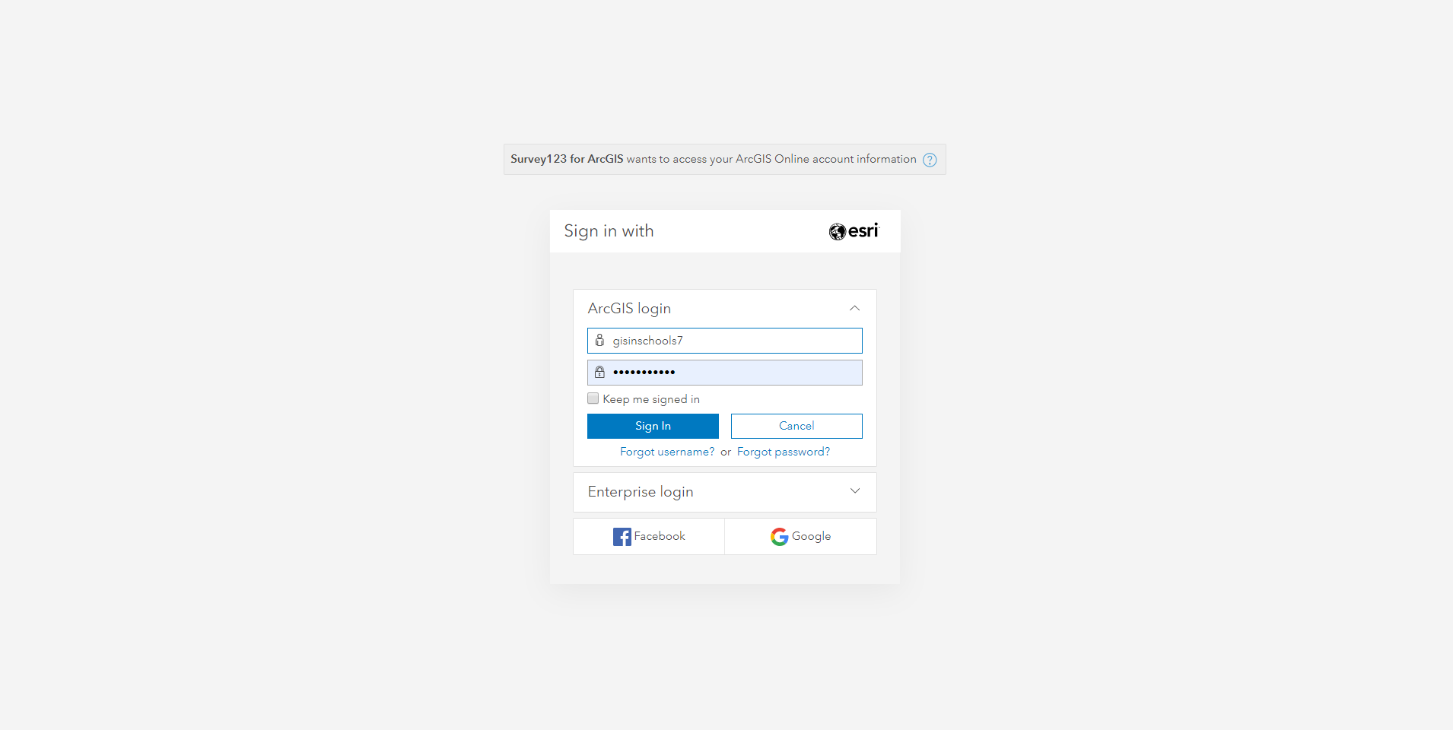
- Click Create a New Survey

- When the box below appears, select Get Started on the Using the web designer

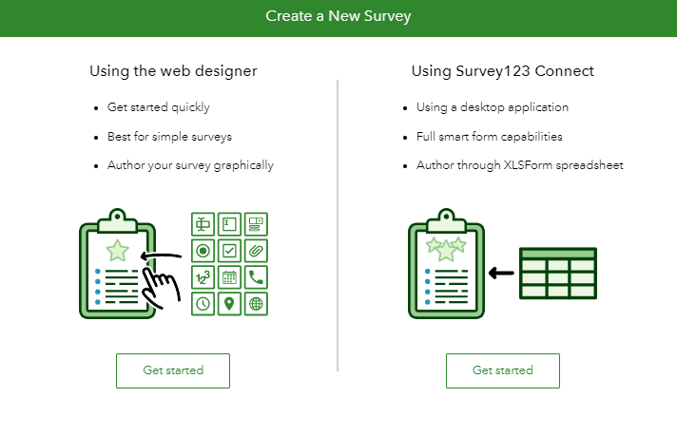
- When the box below appears fill in the following details:
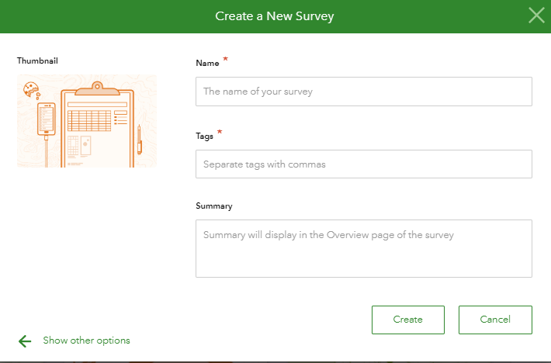

Name:
River Study
Tags:
River Study
Summary:
River Study using Survey123

- Click Create
- Start filling in the questions to get data like the csv file in your lesson pack

Question One:
- Click Single Choice Question 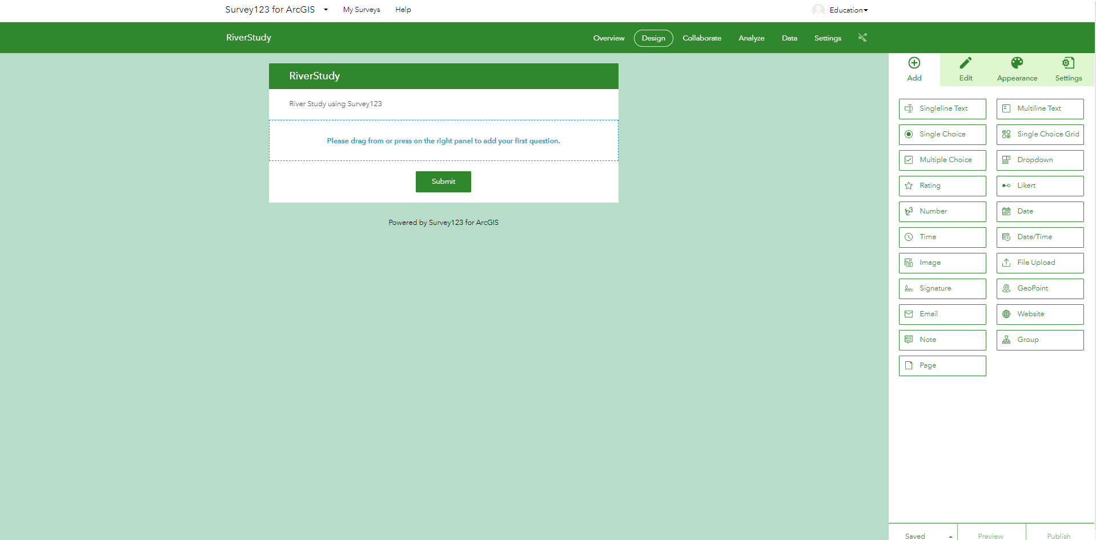
- Drag Question into the first question box
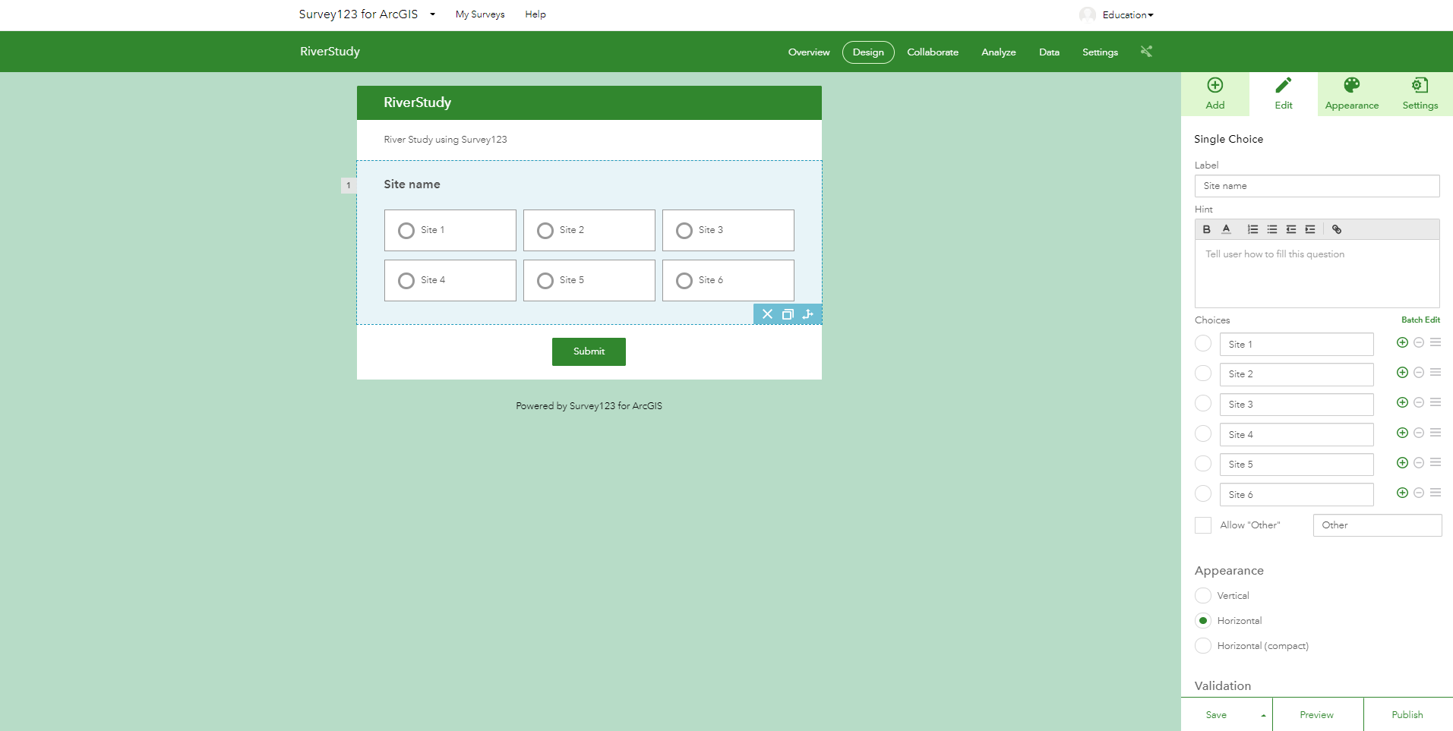
- Fill in the question details like the image above

Label:
Site Name
Choice:
(Click the plus icon 5 times to give you 6 choices and label them as follows):
Site 1
Site 2
Site 3
Site 4
Site 5
Site 6

- For appearance tick Horizontal
- Click Save

Question Two:
- Click Add
- Click Number
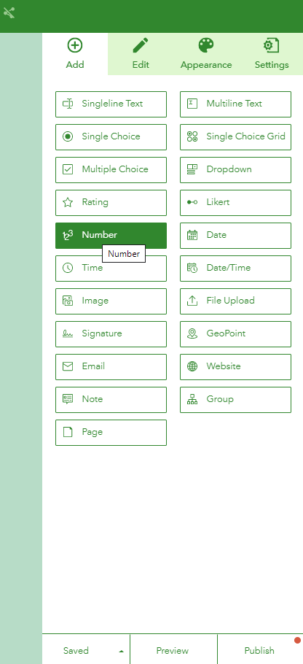
- Fill in question box like below:
- Label
Chanel Depth
- For hint, type in
In Meters
- Click Save
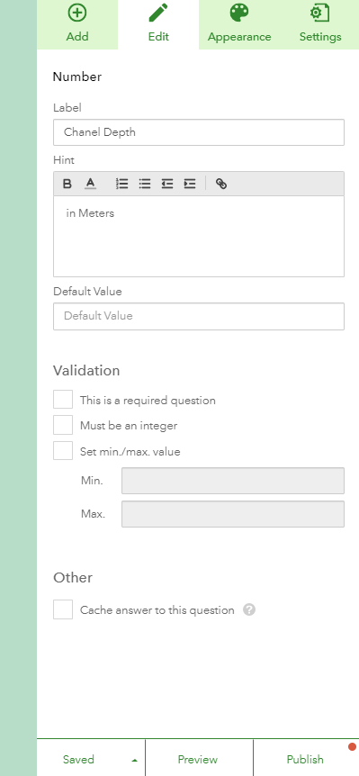

Question Three:
- Click add again,
- Click Number and fill in details like below:
Label:
Channel Width
- For hint, type in
In Meters
Click Save

Question Four:
- Click add again,
- Click Number and fill in details like below:
Label:
Wetted Perimeter
- For hint, type in
In Meters
Click Save

Question Five:
- Click add again,
- Click Number and fill in details like below:
Label:
Distance
- For hint, type in
In Meters
Click Save

Question Six:
- Click add again,
- Click Number and fill in details like below:
Label:
Mean Time
- For hint, type in
In Meters
Click Save

Question Seven:
- Click add again,
- Click Geopoint and fill in details like below:
Label:
Mark Where you are on Map
- Change the Default map to Imagery with Labels
- Tick the tick box for ask for the device’s location when opening this question
- Set the default location to Belfast
- Tick this is a required question
- Click Save

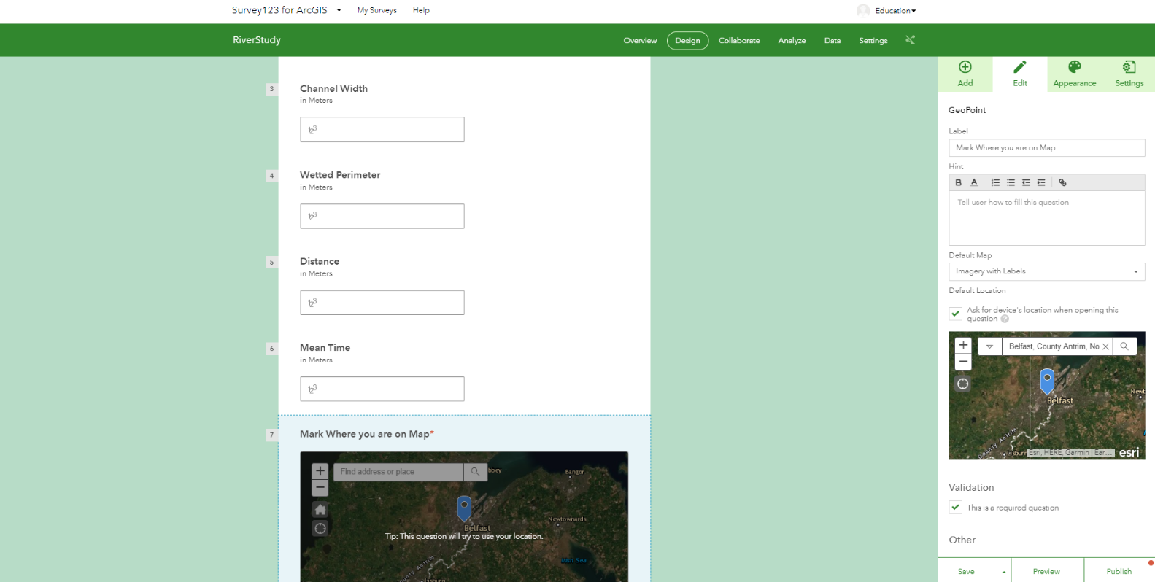

Question Eight:
- Click add again,
- Click Image and fill in details like below:
Label:
Take a Photo
- Tick this is a required question in all cases if you require a question
- Do not tick it in this example
- Click Save

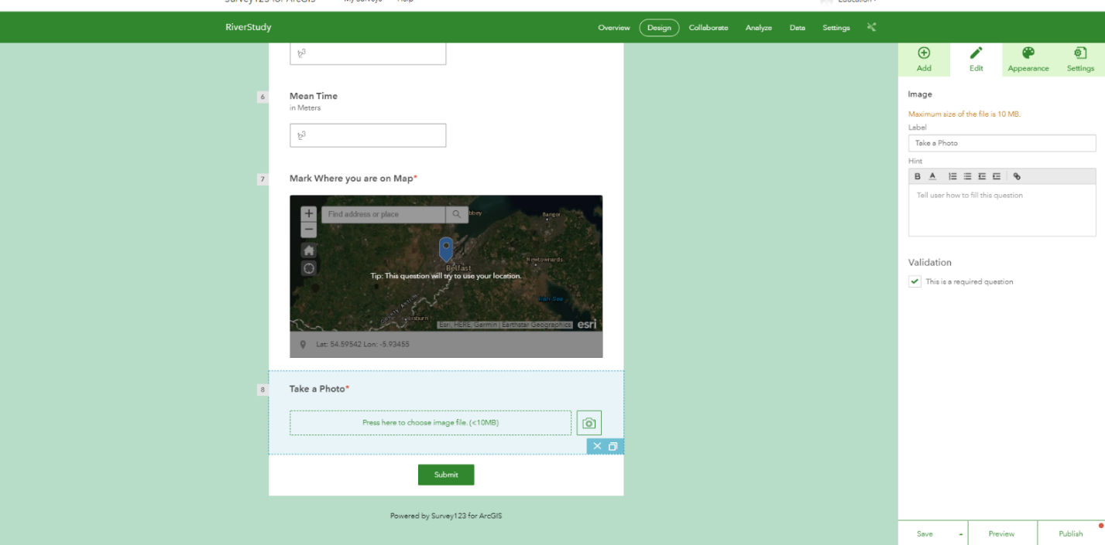

- Click Publish and ok
- This will publish your survey123 survey online so that you can view the survey on the Survey123 app or in a browser
- This will also add the survey into a folder in your My Content in your ArcGIS Online account for your school
- The survey will be there when you login to https://www.arcgis.com/home/index.html and go to My Content
- The survey will be called a feature layer and if you click on this, it will ask you if you want to view the survey layer in a map viewer. This is how you see the results points on the map collected from your surveys.
- We will do this in the next part of today’s workshop

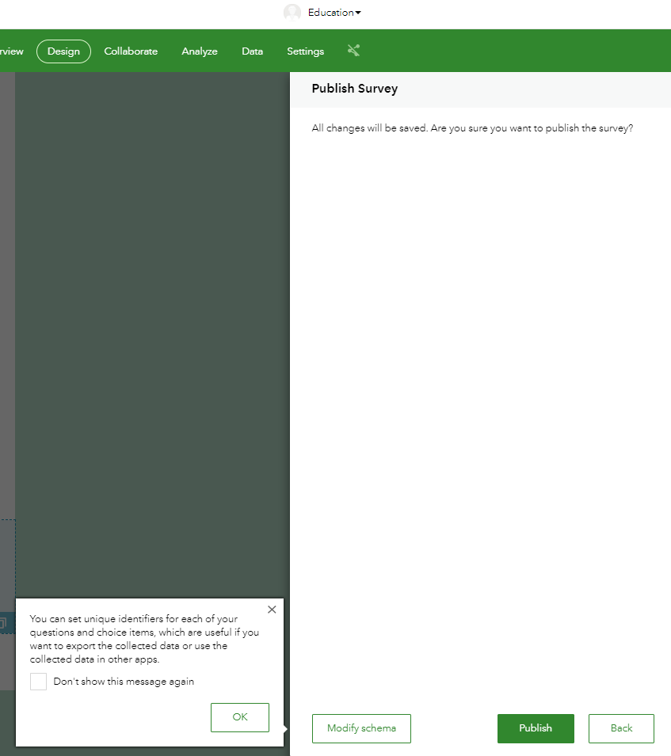

Sharing your Survey with you class:

- Click Collaborate

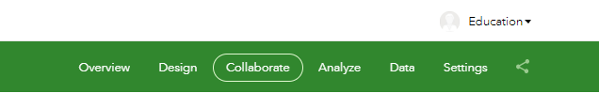

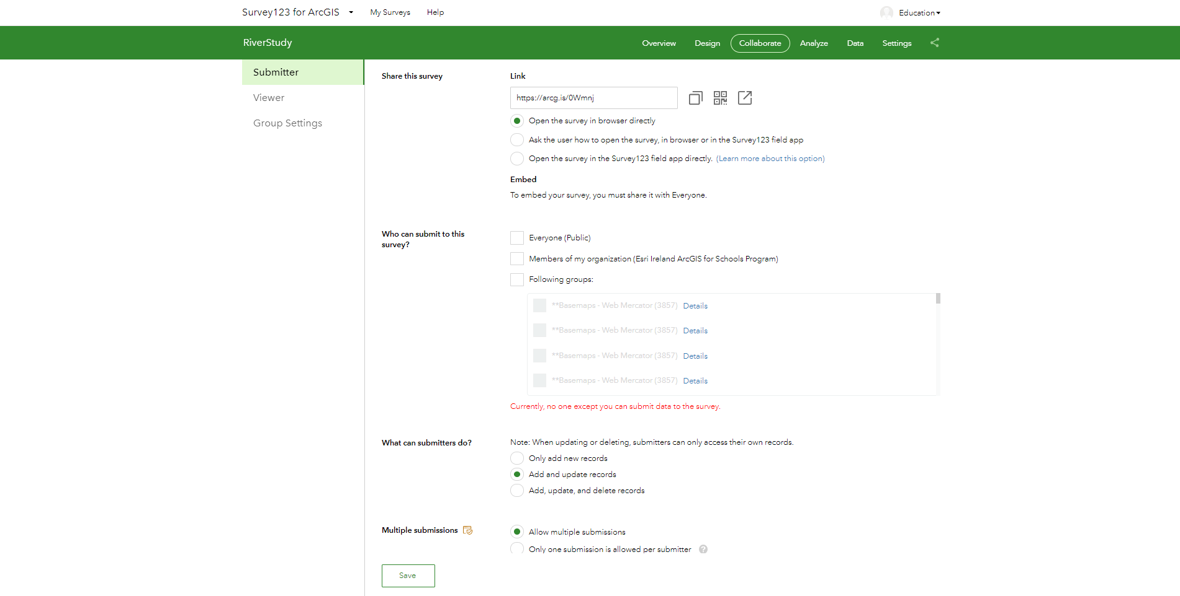

- Click the tick box for:

Who can submit to this survey?

- Tick Everyone

- Tick Save

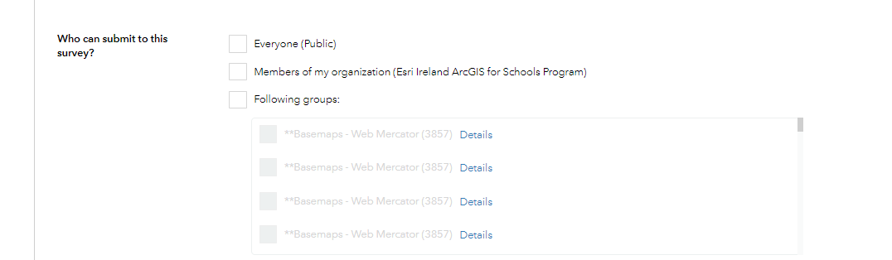

(Note that you can share survey with only your school or a group of students in your school if you have a class group set up)
- Notice the area in this window called:

Share this survey

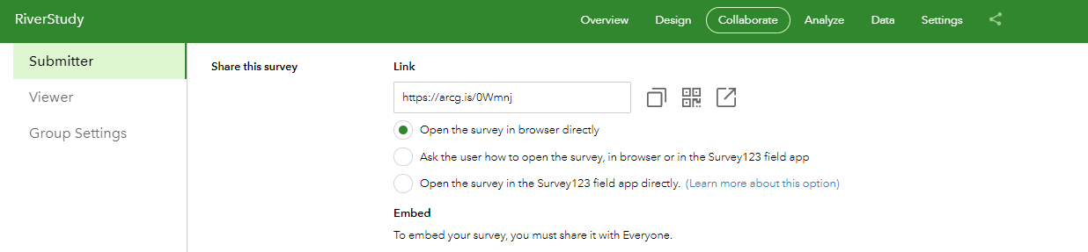
- You will see a link here to your survey
- Copy short url in link box and paste into your browser to open survey
- Make sure survey is shared publicly

Part Two:
Collect some Survey Points using Survey123

- Open the survey you just created in your browser
- We will complete Survey next by filling in the survey 6 times
- Click submit each time you fill in the survey and refresh your browser to open up the survey again to collect a new point
- Pick a River close to you town on the map and fill in 6 Collection Sites along this river using Survey123 and the image below with information for each survey you fill in

i.e.
each row in the table below is a new survey

There are 6 rows in the image below meaning 6 surveys

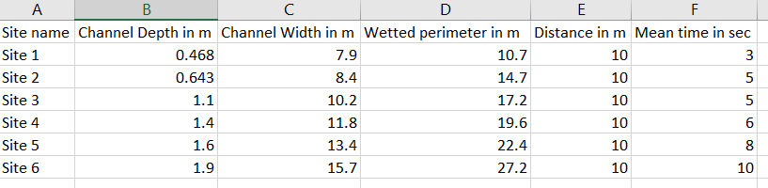

Part Three:
- How to do analyze River Study Results once back in the Classroom using ArcGIS Online

- Imagine you are now back in the office after completing your survey
- Login to ArcGIS Online with the login you were given today

https://www.arcgis.com/home/index.html

- Click Content
- Click My Content

- See folders and notice your RiverStudy folder
- Click on it to view files
- Click on

RiverStudy Feature Layer (hosted)

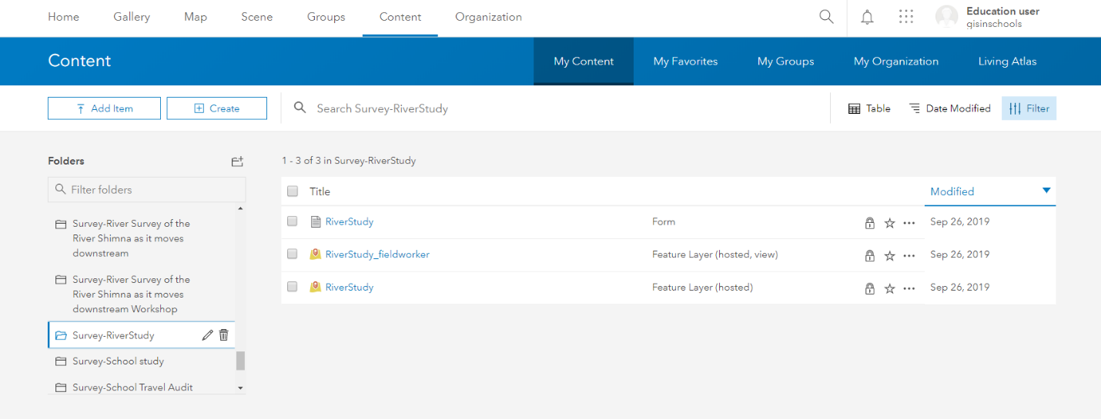

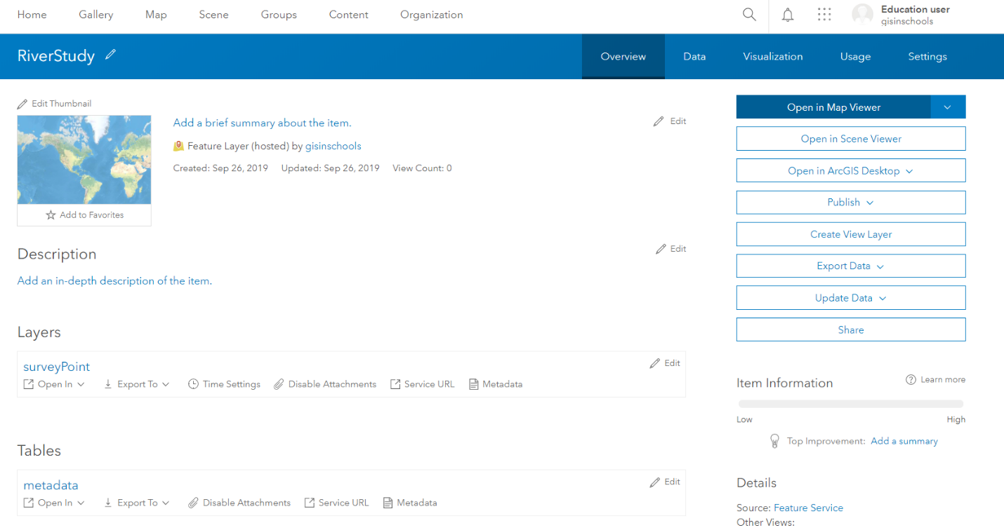

- Your Map viewer will open and you will see your 6 survey points that you just collected on the map
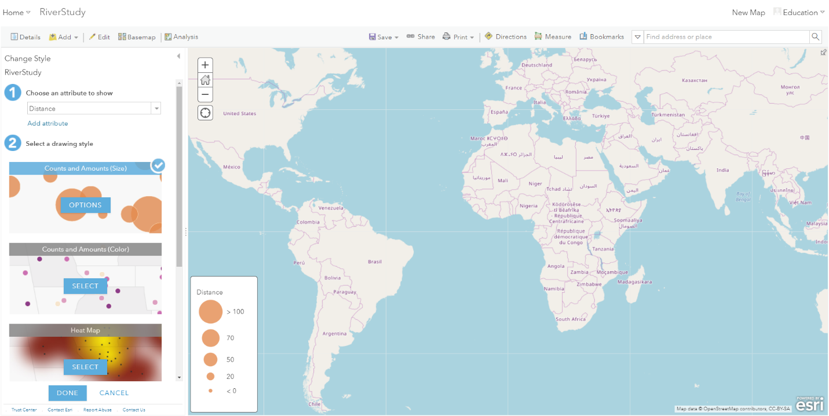
- Smart Mapping in ArcGIS Online will try and symbolize your questions

For example: Distance

- Scroll Through the questions in the:

Choose an attribute to show dropdown:

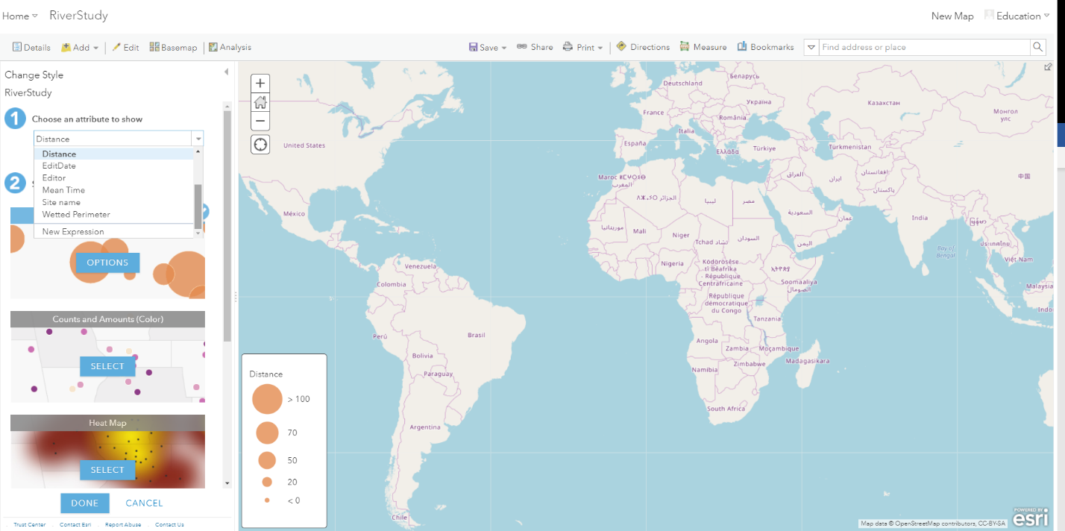
- Pick Site name
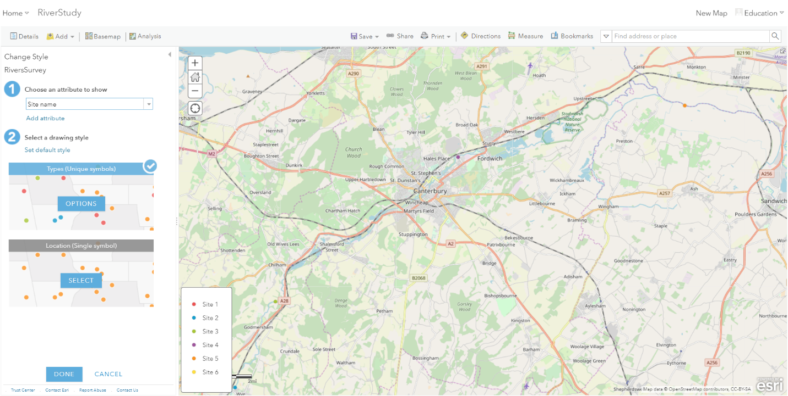
- Click Done
- Click Save
- Click Save As
- Fill in the save as box that appears like below image and click save as:

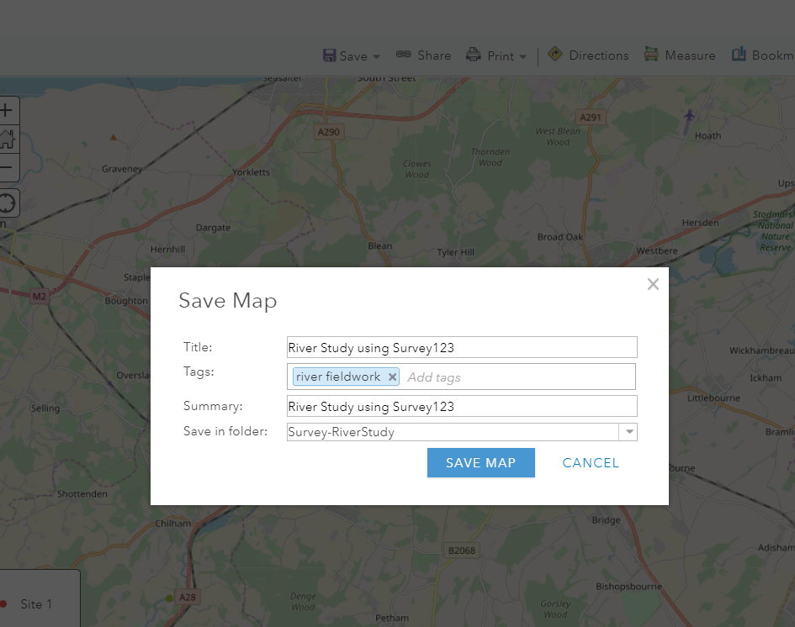

- Next we will explore these points and do some analysis of our results

Part Four:
Calculate Cross Sectional Area, Hydraulic Radius, Velocity and Discharge using ArcGIS Online

- The following steps are outlined in the link below:

https://sway.office.com/KE5jPcfwYEgvhTic

- The sample data used in todays workshop is from the river Stour in kent
- The fieldwork spreadsheet given to you in your lesson pack today contains all of the data required to calculate the Cross Sectional Area, Hydraulic Radius, Velocity and Discharge of a river
- To get started with your calculations you will to open the Table of the data from your surveys on your map by clicking the Spreadsheet icon

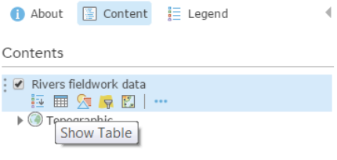
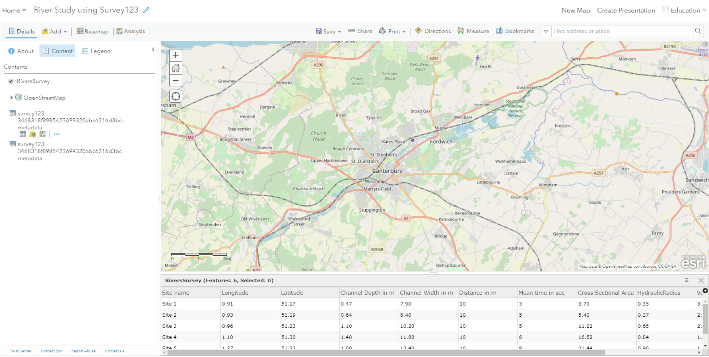

- Next we are going to start working with our tables of data in ArcGIS Online
- The formula for calculating the Cross Sectional Area of a river is:

Channel width x Channel depth

- The answer to this calculation needs to go into a new column in the data table.
- This is done by selecting Table Options
- Click Add Field

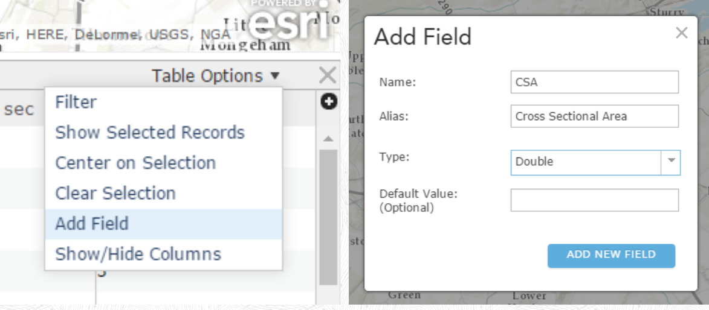

- In the Add Filed window fill in the boxes as shown in the image above and click Add Field

Note: Double means numbers with decimal places
- You can see a new filed being added to the table

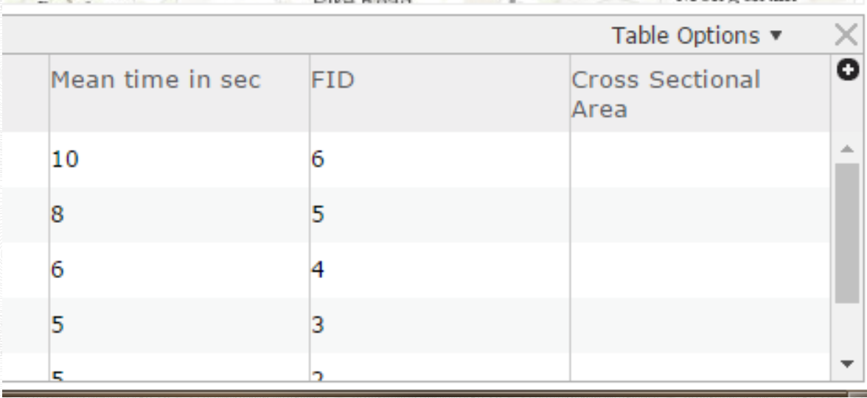

- Next we will start to calculate new primary data
- To open the calculation Expression Builder click Calculate as shown in the image below:

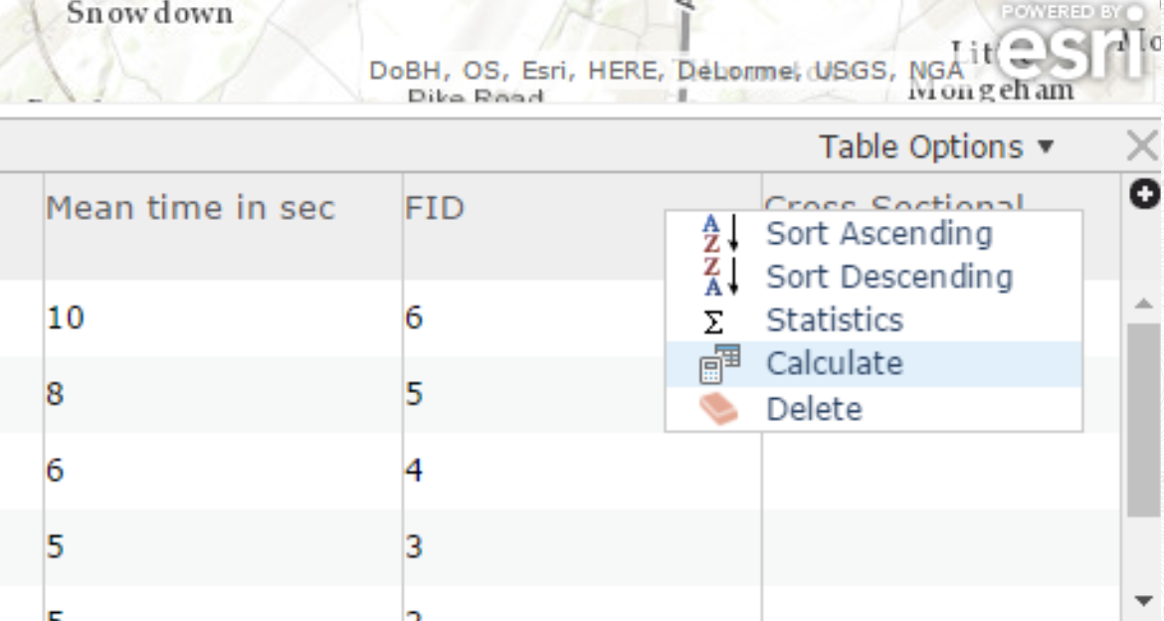

- Click SQL when the box in the image below appears:

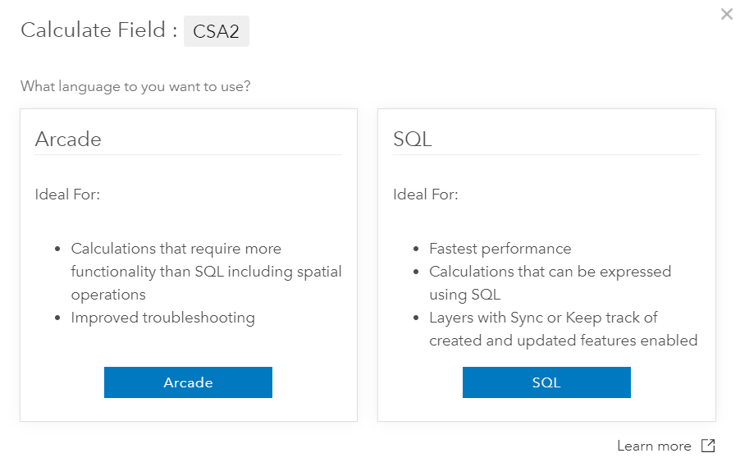

- In the Expression Builder simply click on the items that need to be calculated, in this instance:

Channel_Depth_in_m *Channel_Width_in_m
* equals multiply

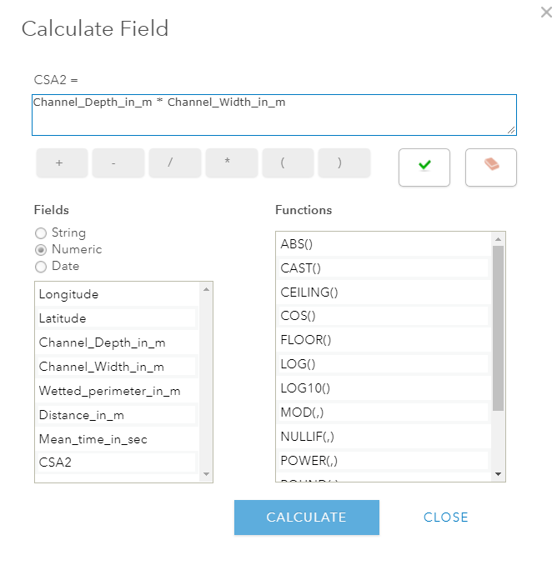
- Once you click calculate and click on the table for the layer, you will see that the Cross Sectional Area has been calculated for all of the fieldwork locations
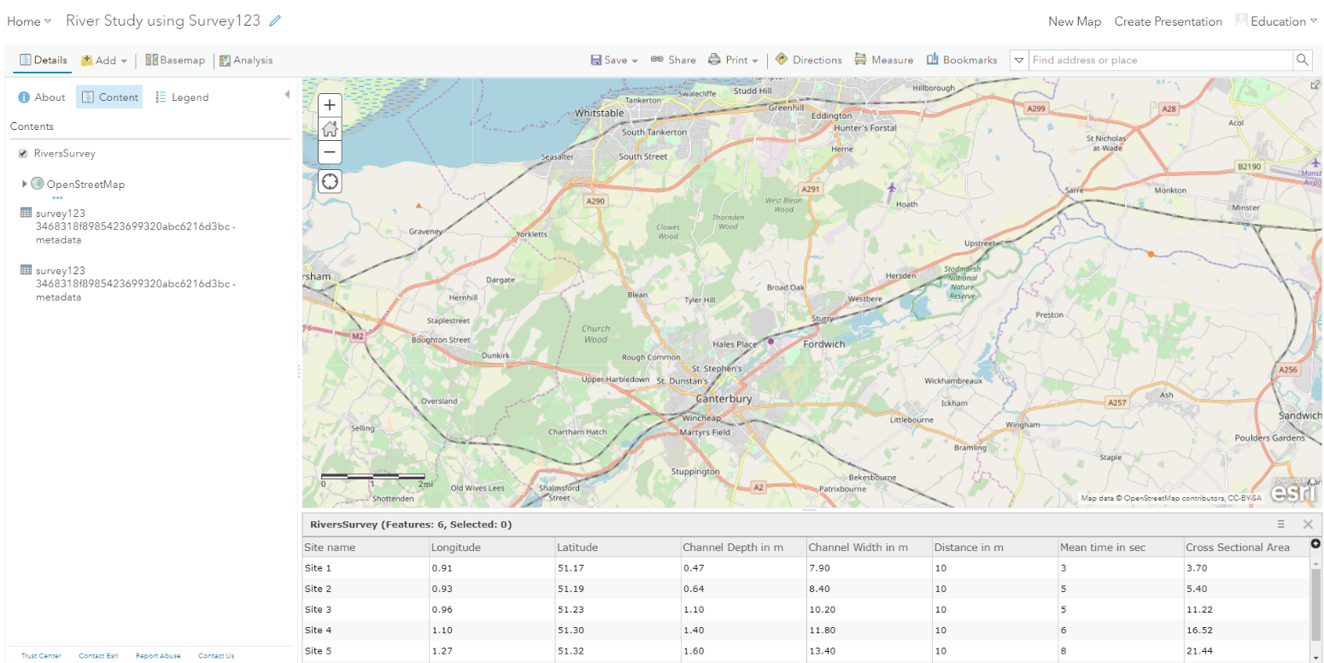

Calculating Hydraulic Radius, velocity and Discharge:
Using the process set out above and the formulae set out below, calculate:

- Hydraulic Radius = cross sectional area ÷ Wetted perimeter
- Velocity = distance ÷ Mean time
- Discharge = mean velocity x cross sectional area

Calculating Hydraulic Radius:

- Click the table icon again on the RiverStudy layer
- When the table opens click the

- Click Add Field

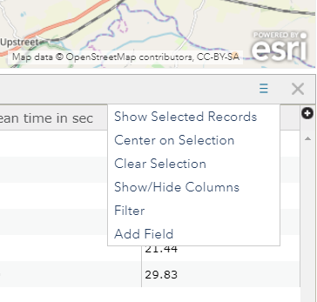
- Fill in the field box like below, calling it Hydraulic Radius and making it a Double field

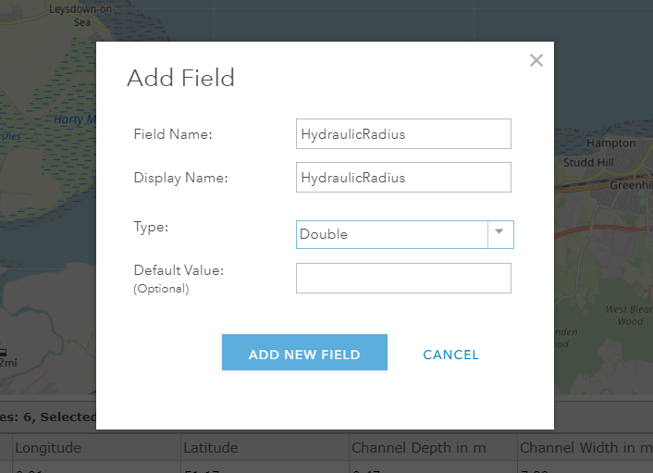

- Click Add field

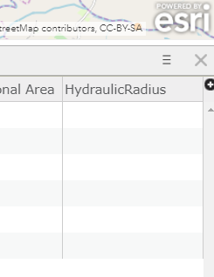
- Click on the Hydraulic Radius field to see options

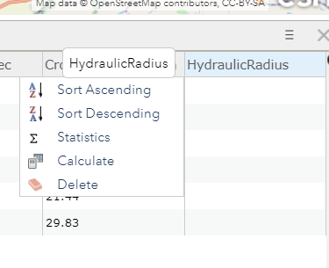
- Click Calculate
- Click SQL
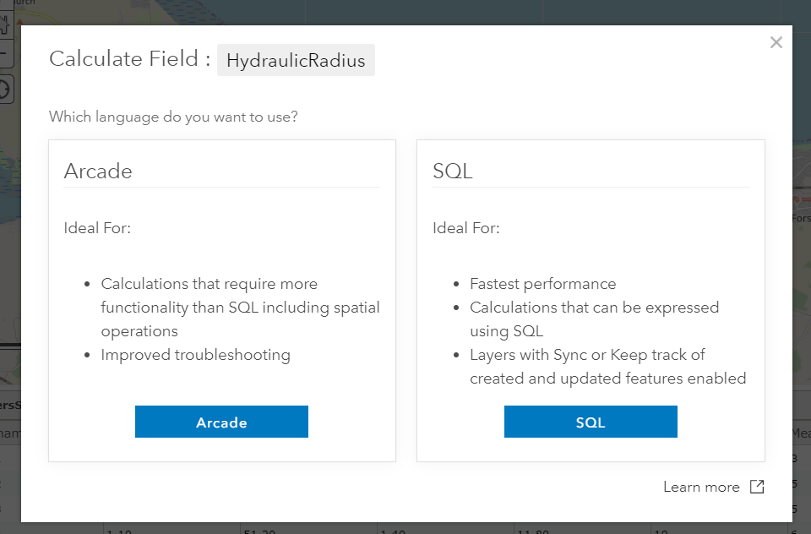
- Fill in the equation like the image below:

CSA / Wetted_Perimater_in_m

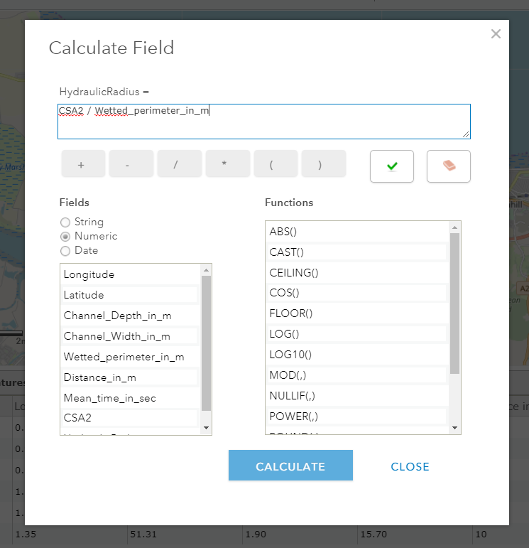
- Click Calculate

Calculating Velocity:

- Click the table icon again on the RiverStudy layer
- When the table opens click the

- Click Add Field

- Fill in the field box like below, calling it Velocity and making it a Double field

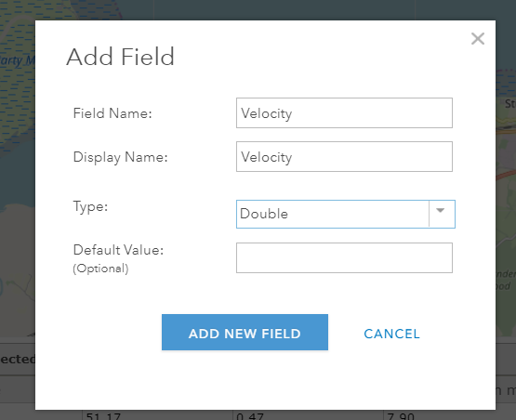

- Click Add field

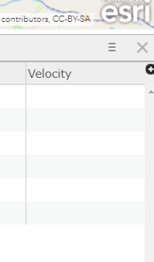
- Click on the Velocity field to see options

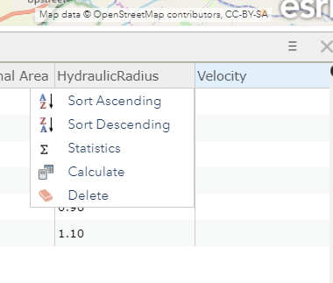
- Click Calculate
- Click SQL

- Fill in the equation like the image below:

Velocity = Distance_in_m / Mean_time_in_sec
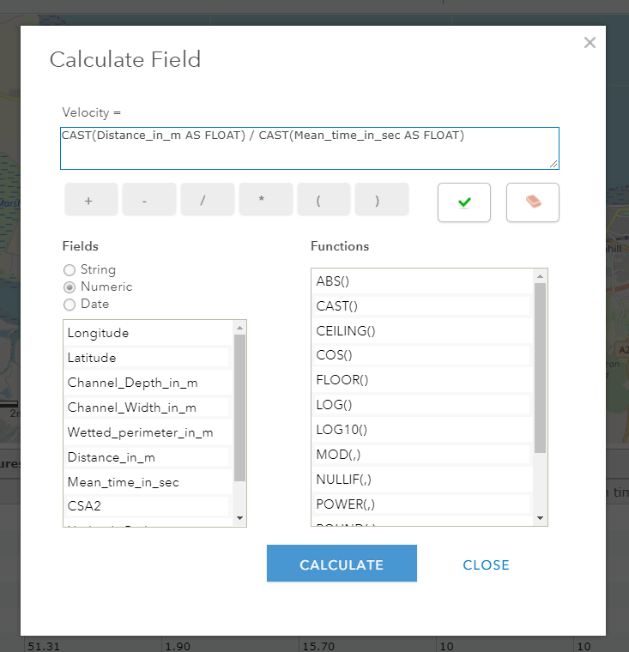
- Click Calculate
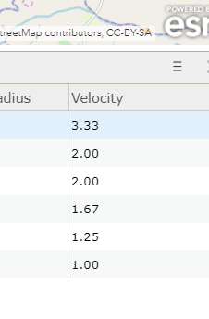
Calculating Discharge:

- Click the table icon again on the RiverStudy layer
- When the table opens click the

- Click Add Field

- Fill in the field box like below, calling it Discharge and making it a Double field

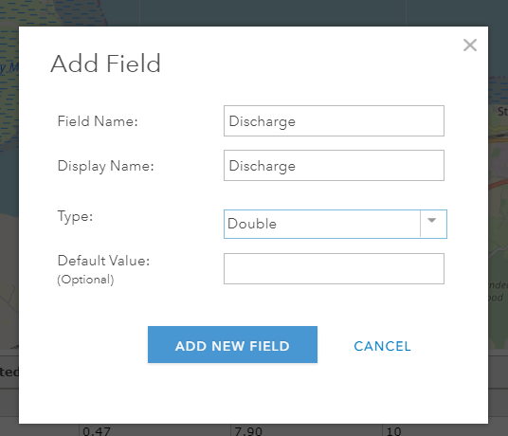

- Click Add field

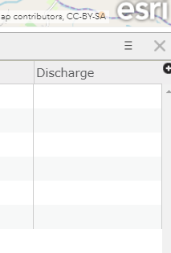
- Click on the Discharge field to see options

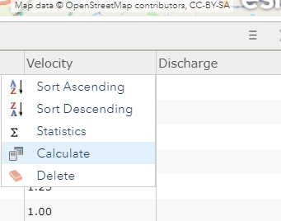
- Click Calculate
- Click SQL

- Fill in the equation like the image below:

Discharge = mean velocity x cross sectional area
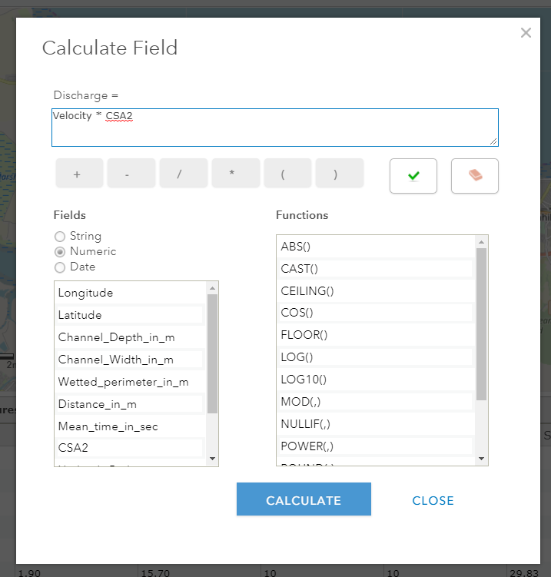
- Click Calculate

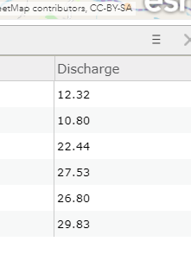

Thanks to the Field Studies Council for the Formulas
https://www.field-studies-council.org/

Credit to Jason Sawle – Schools Education Manager at Esri UK who put together the River study guide in the link below that this guide was adapted from:
https://sway.office.com/KE5jPcfwYEgvhTic

