How to Digitise Land Use Surveys

You might want to create a digital copy of land use surveys for a number of a reasons. Easily visualising change over time, calculating area coverage, sharing your findings without needing to photocopy paper maps are just a few. You can easily do this using ArcGIS Online.
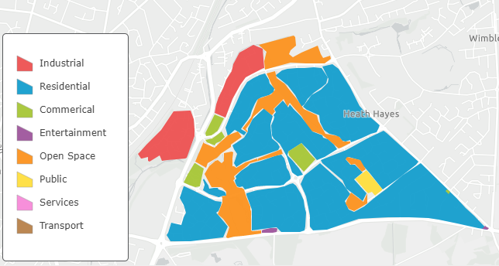
Figure 1: Draft land use survey using RICEPOTS characterisation framework

Step One: Adding an editable feature layer
This is the digital equivalent of collecting tracing paper to lay over an OS Map – it is where you are going to draw blocks of land within the GIS.
There is a Land Use survey layer which uses the Field Studies Council RICEPOTS characterisation schema ready for you to use in ArcGIS Online (NB You can change these category labels, if you need to, in the Change Style Menu).

- Login to your account and go to the Content page.

- In the top left of the page is the Create button. Click it and select Feature Layer from the dropdown menu.
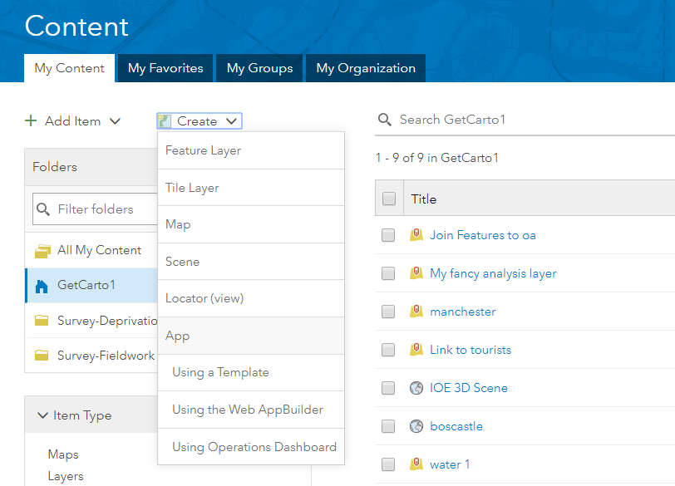
- A new menu will appear. Click From URL on the top ribbon.
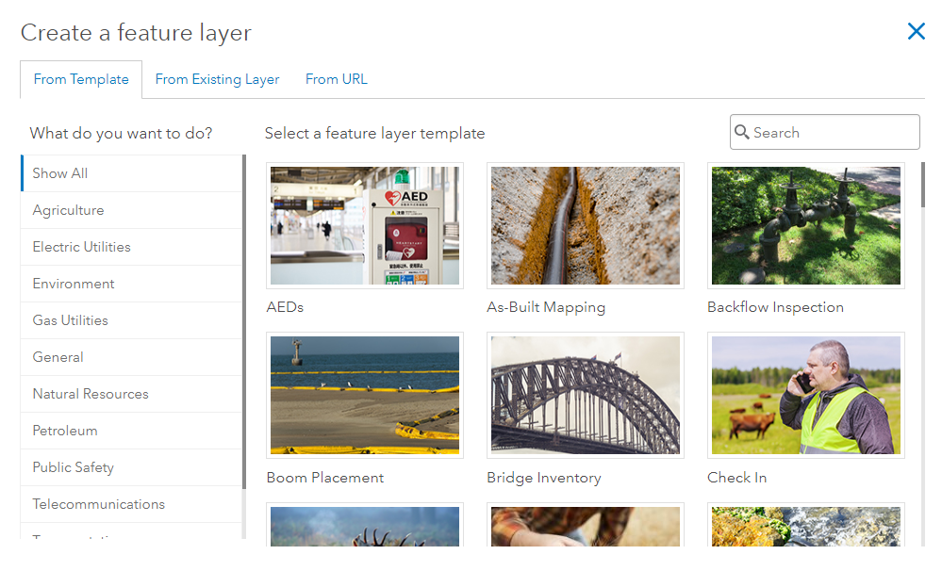
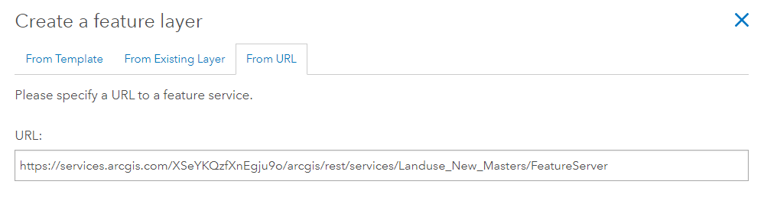
- Copy the following URL into the box that appears: https://services.arcgis.com/XSeYKQzfXnEgju9o/arcgis/rest/services/Landuse_New_Masters/FeatureServer

- Click Next. You can change the name of your new layer if you want, from the default land_use_survey. Just click on the name to change it. Then click Next again.
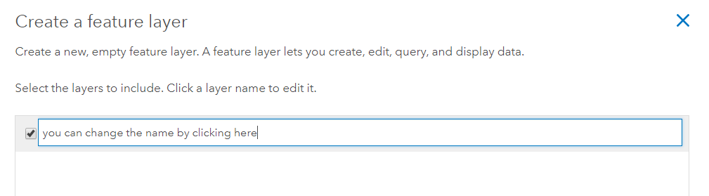
- You can set the extent of your layer on the next page by zooming in or out of the map. Leaving it as the default (the UK) will be fine for any UK land surveys. Click Next when you’re happy.
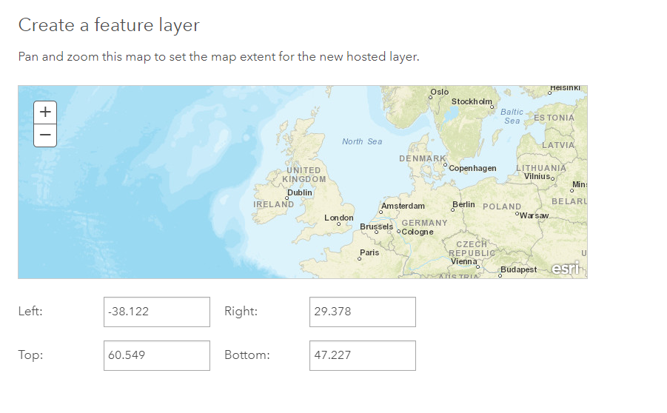

- Enter a title and some tags for your new feature layer. Use something that will be clear and easy to find later on! Then click Done.
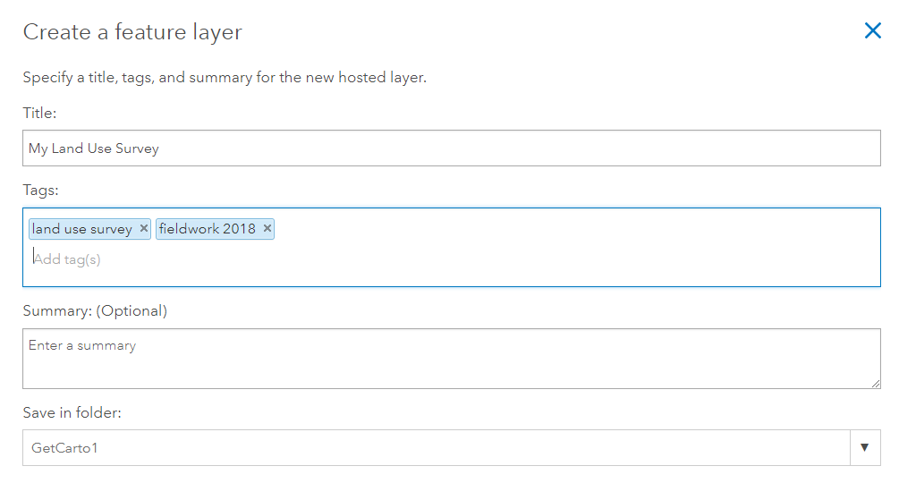
- Your new feature layer will appear on the screen. Click Open in Map Viewer to start digitising your land use survey!

Step Two: Digitising Your Land Use Survey

- Open your new feature layer on a map. Land Use Type should be the default attribute you want to show. Click Done.

- Zoom in to/search for your area of interest. In this example I’m looking at the town of Cannock, Staffordshire.

- Pick an appropriate basemap that shows the building outlines you’re interested in. OS Maps are probably the most detailed.
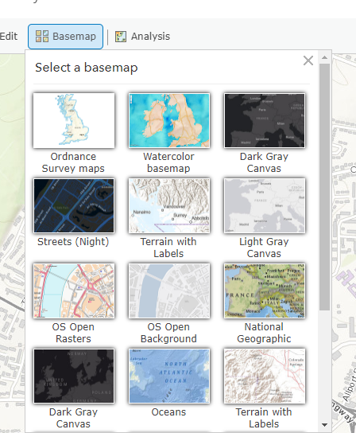

- Click on Edit (from the top ribbon). A new menu will open, showing different land use types you can add to the map. Click on the type you want to map. In this example I’m going to use residential.
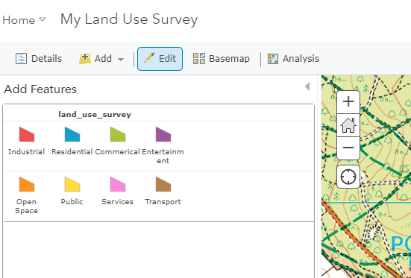
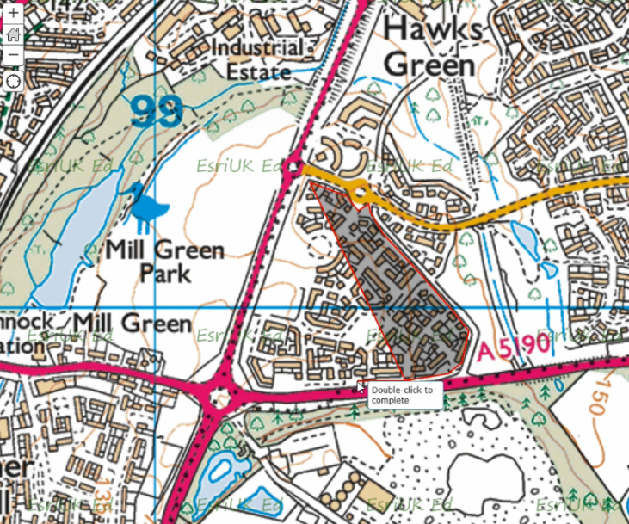
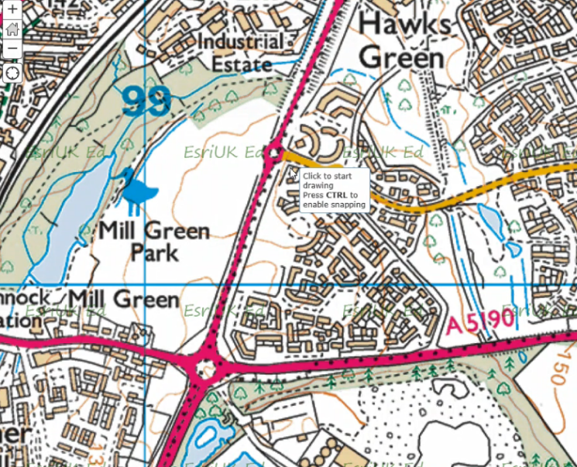
- On your map, left-click where you want to start drawing. Click again, following the edge of the parcel of land, or even a specific building. The GIS will draw the shape you outline. Double click to finish, and a polygon will appear on your map.

Click here to see a video of this process

- You can add more polygons for each unit of land you’re interested in mapping, until you’re happy with your map. To stop editing and save all this work, you need to click the Edit button to finish.
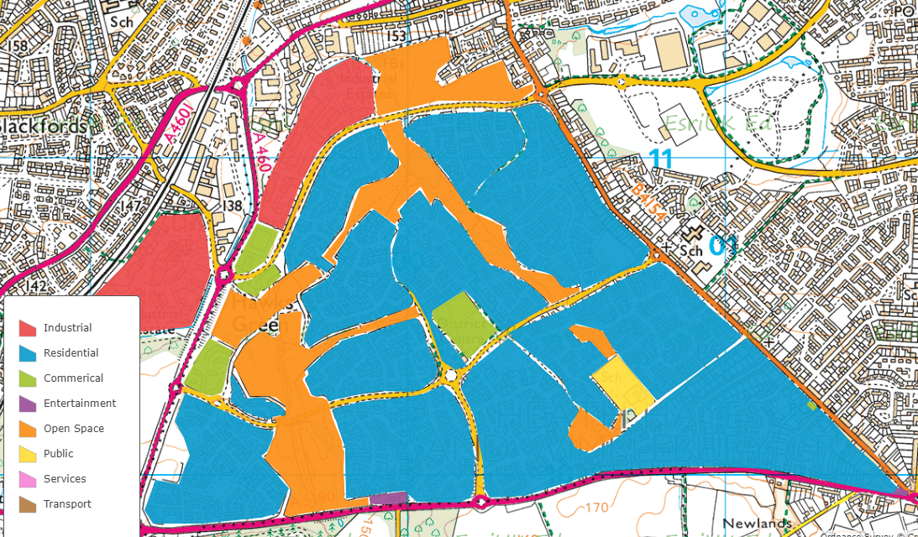

Step Three: Going Further
- If you want to change the labels (e.g. change ‘residential’ to ‘housing’) click Change Style button -> Options -> click on the label you want to change to type a new name.
- A digital land use map lets you compare data from different years at the click of a button. Can you see the effects of processes like gentrification or dereliction in your study area? How do you know?
- Is there a relationship between land use and reported crimes? Add data.police.uk crime statistics to your map and find out!
- Create your own land use survey feature layer at https://developers.arcgis.com/layers/new

Questions, comments or feedback?
Please email schools@esriuk.com or tweet @geogologue or @GIS4Schools

