ArcGIS for Schools Practical Guide for today’s
Earthquake Workshop

This workshop will show you how to examine Earthquakes in ArcGIS Online and how to create a web map with data already in ArcGIS Online

This workshop can also help you teach one of the learning outcomes in Strand 1: Exploring the physical world of Junior Cycle Geography or even can be used as a topic for a Classroom Based Assessment:

1.1 Describe the formation and global distribution of volcanoes, earthquakes, and fold mountains in the context of plate tectonics and structure of the earth

Earthquakes are happening all the time all over the world as the earth moves and because of this we would like to go through how to find GIS data in ArcGIS Online and investigate the distribution of recent earthquakes on a map.

In this workshop we will explore the earthquakes that happened recently in Chile and explore reasons for why they happened through data we find in ArcGIS Online.

Part One Steps: Adding data into ArcGIS Online

- Login to https://www.arcgis.com/index.html with the login you were given for today’s workshop.
- (or go to Google and type in ArcGIS Online)
- Click Map

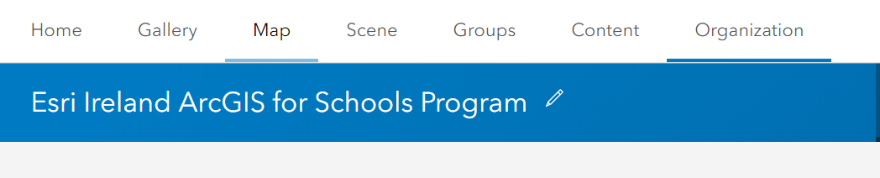

- Click Add and then Search for Layers

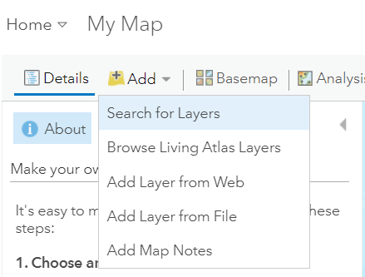

- Click the dropdown arrow and click My Organisation
- Type in the tag word:

workshop

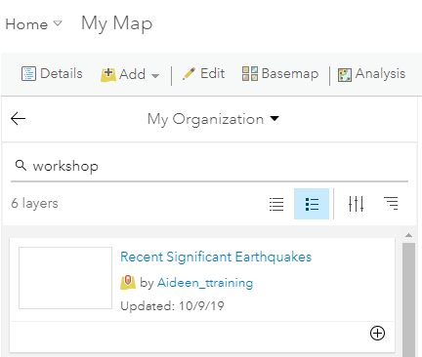

- You will see a layer called:
Recent Significant Earthquakes

That we will use in today’s workshop

- Click the plus icon to add the layer to the map
- This will automatically display all earthquakes across the world that happened recently

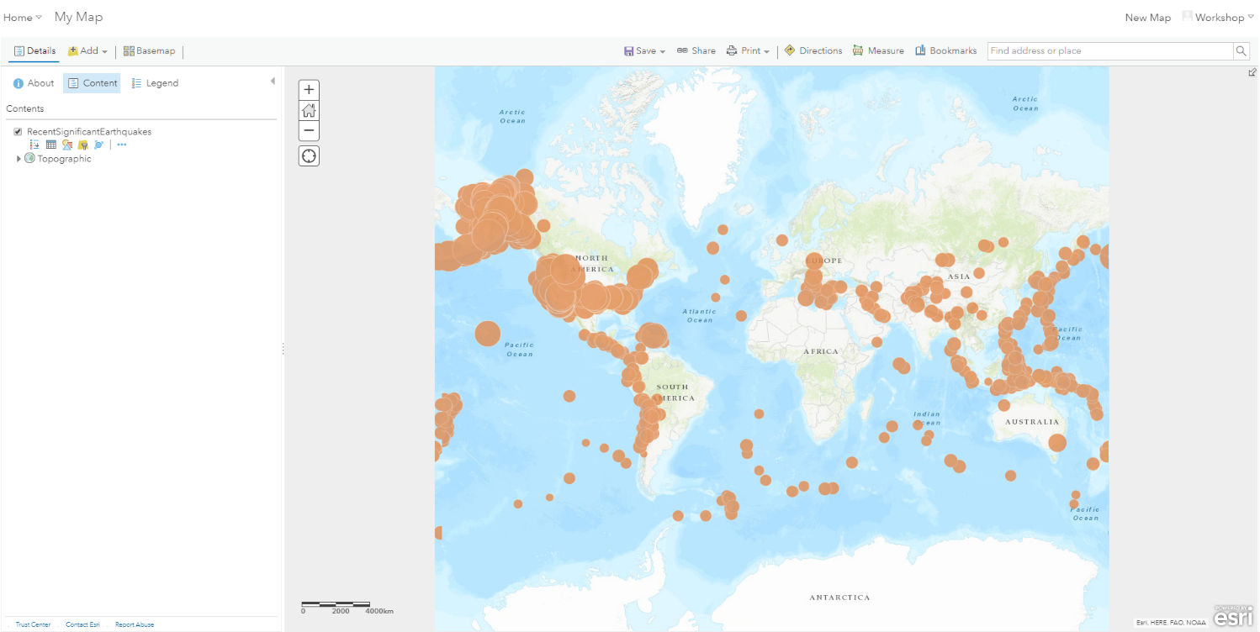
- Click the Back arrow

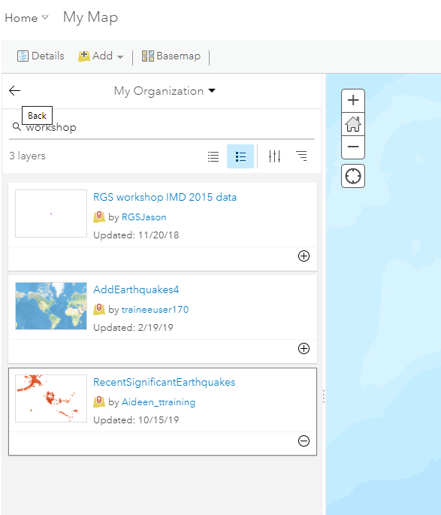

- Click Content

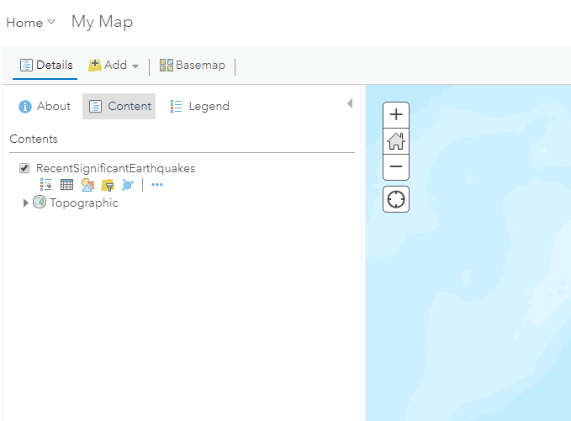

- Hover under the Layer name and you will see different icons appear
- Click the three dots for more options

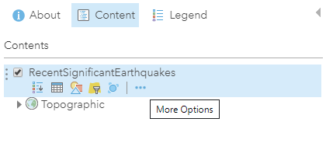
- Click Zoom to

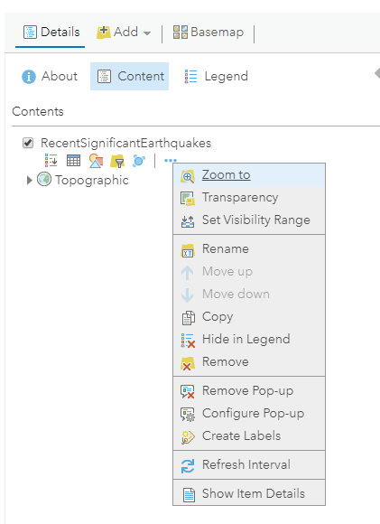

- You will see all the recent significant earthquakes on the map
- Hover over the layer name again to see icons and Click on the second icon for Show Table
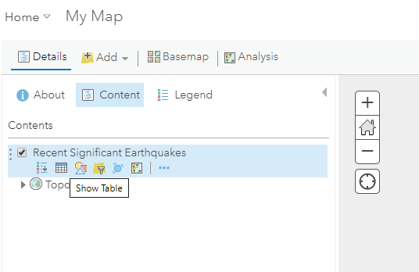

- You will see all the data for each earthquake point on the map including its depth and magnitude
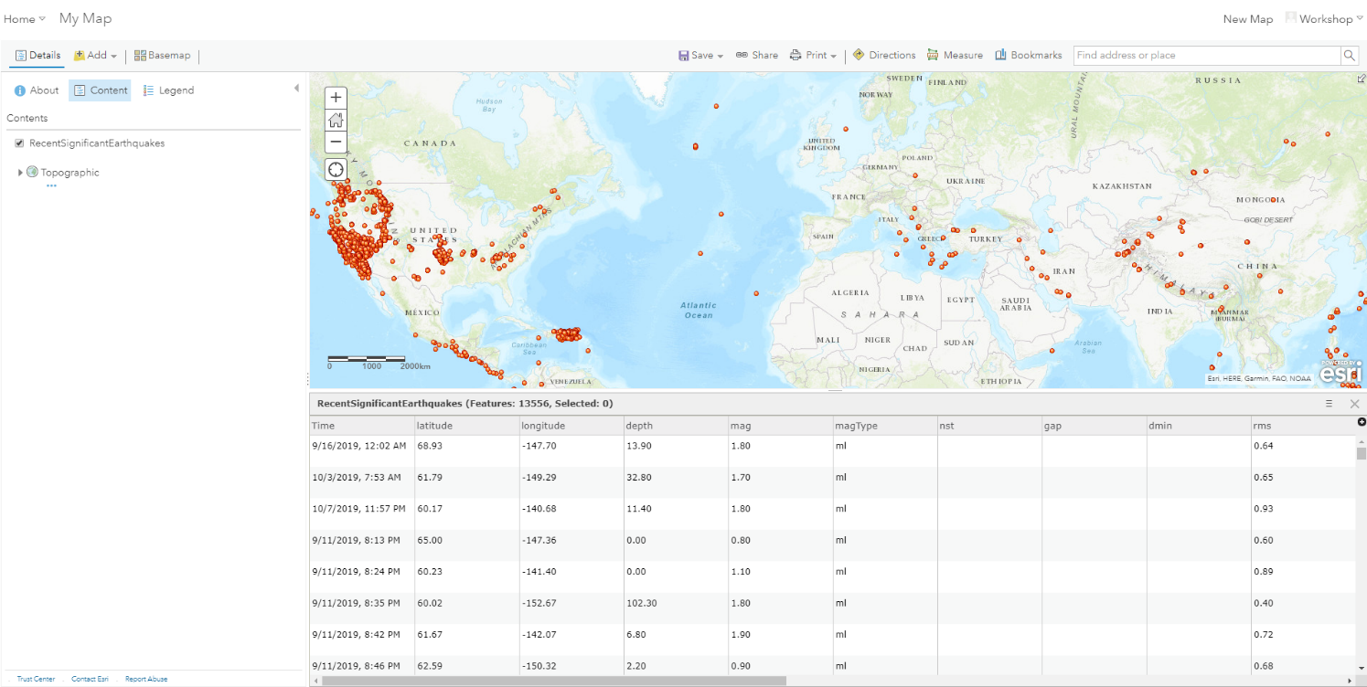

- Click on the third icon for change style

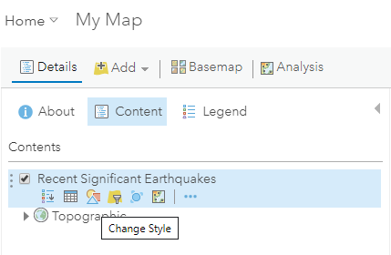
- You will see the window for change style appear with the numbers 1 for Choose an attribute to show and 2 to select the drawing style

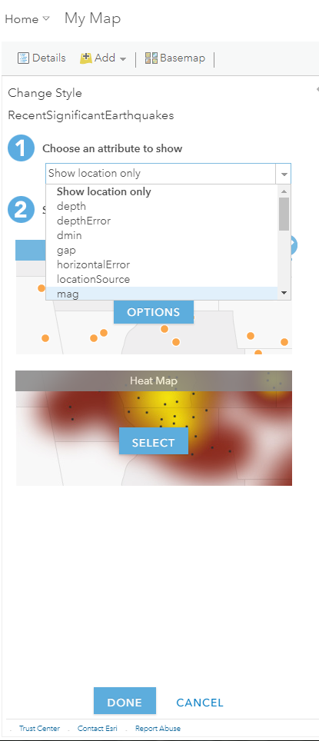
- For 1 use the dropdown and select mag and click Done

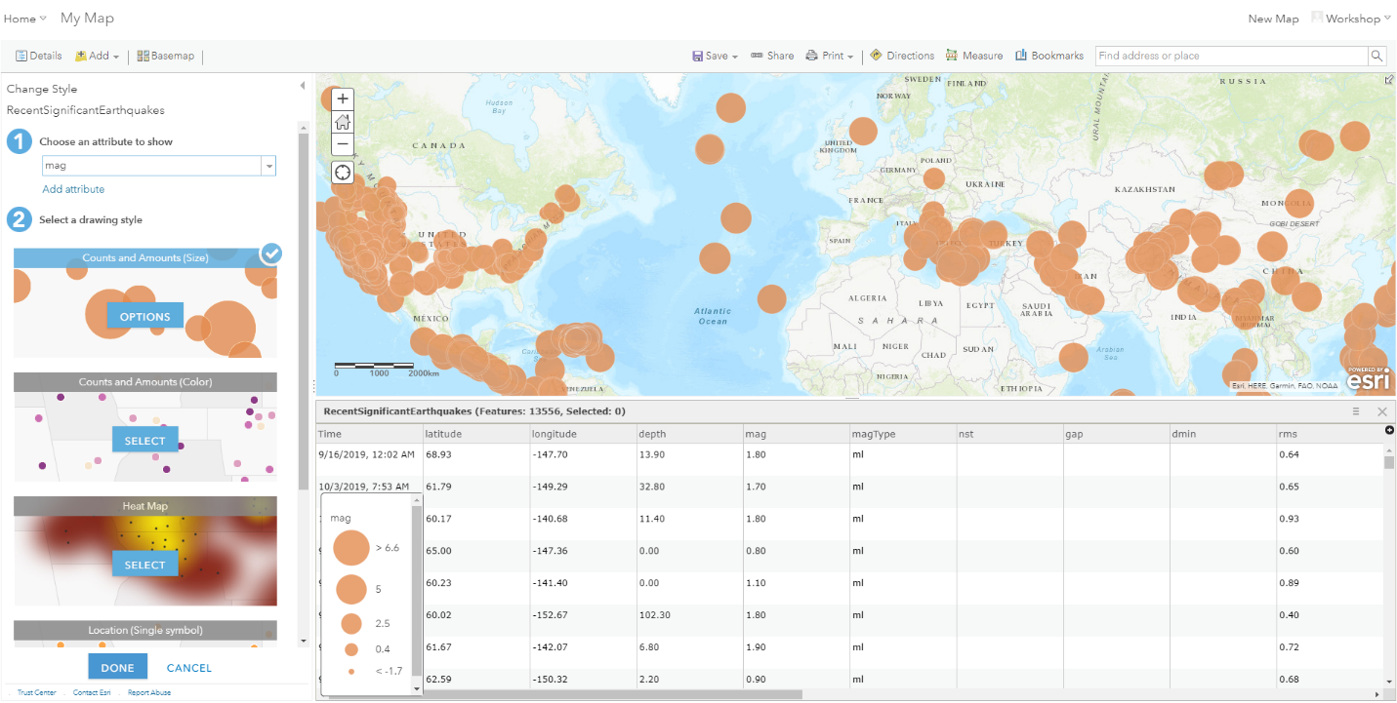
- You will see the earthquakes re-size to the value of the magnitude for the earthquake for each earthquake point across the map
- Click Options in number 2 for Select the drawing style for Counts and Amounts (Size)

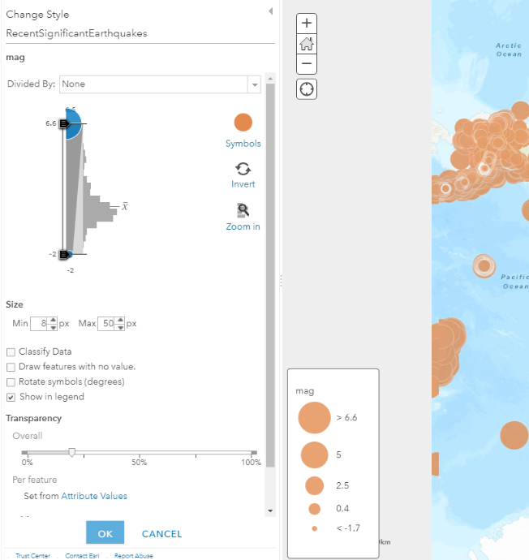
- Click Invert and ok and Done

- You will notice that it will become easier to see the large and small earthquakes across the map if the large earthquakes are smaller points on the map
- Click on the top line in the table window to collapse the table of data from the map or click x on the data table to take it off the map

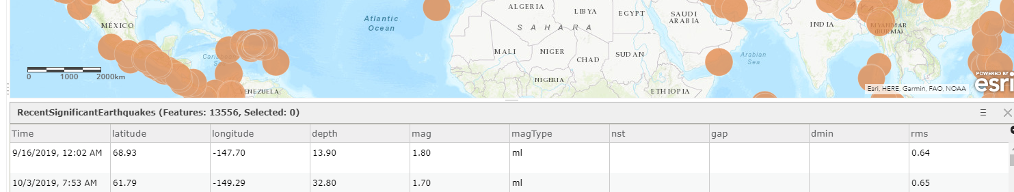

- Click on one of the points to look at the data associated with the earthquake that happened at this location

For example, small dot if it was a large earthquake and large dot if it was a small earthquake by magnitude.
- Click on Find address or place and enter in a place in the world like the examples below and note the earthquakes that happened near these locations
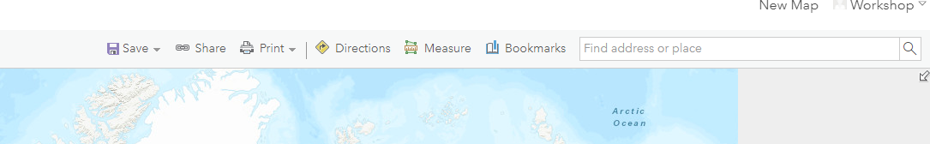

Notice all the earthquakes on the west coast of America thanks to the San Andreas fault or near Chile and El Salvador and a 7.3 earthquake 102km NNE of Laiwui, Indonesia

- Click Basemap

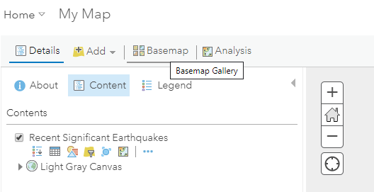

- Click Light Grey Canvas for showing earthquakes
- Scroll between base maps with your class like Imagery with Labels

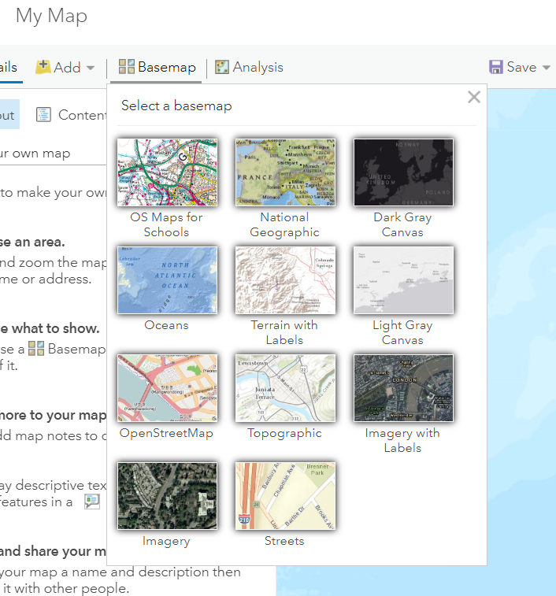

Part Two Steps: Adding layers to the map and searching for an address

Now we will start to explore this and why these earthquakes happened by adding in more data for context to the map from data that we can find in ArcGIS Online
- Next we will learn how to filter data and find layers to the map
- Find an address on the map by entering the following into to Find an Address/ Location box:

Talca, Maule, CHL
- Zoom to this location and Scroll out four times until you see earthquake points just off the coast of Constitucion in Chile

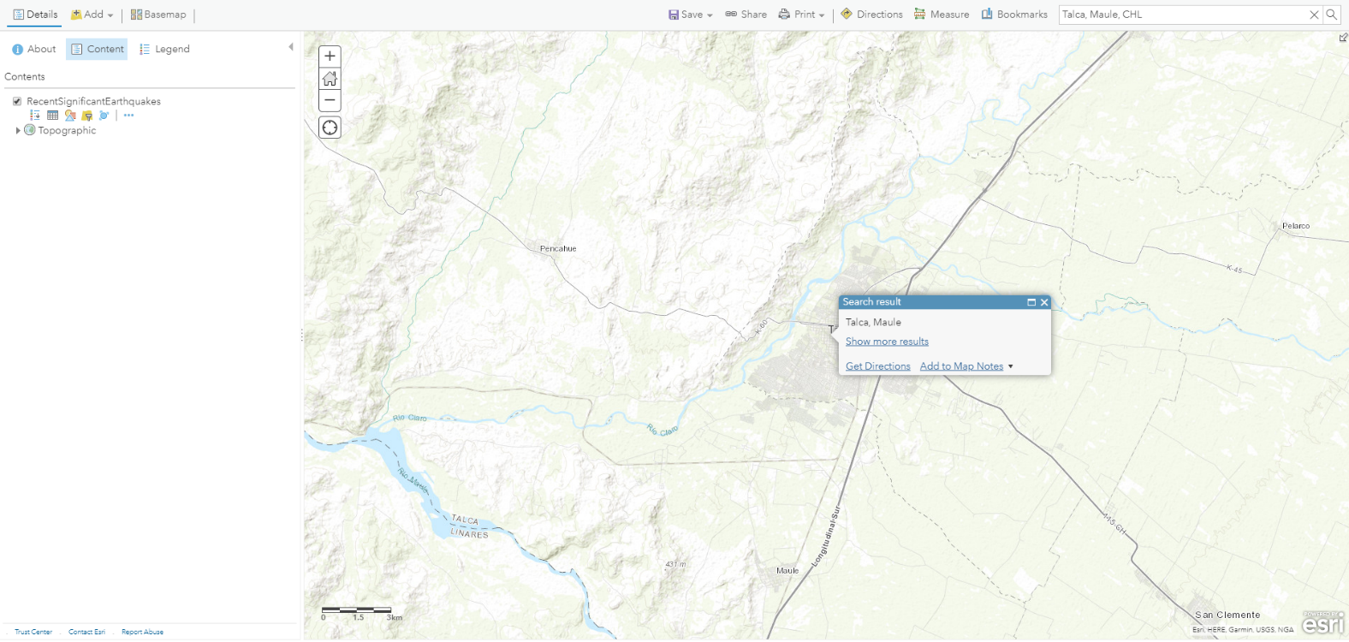
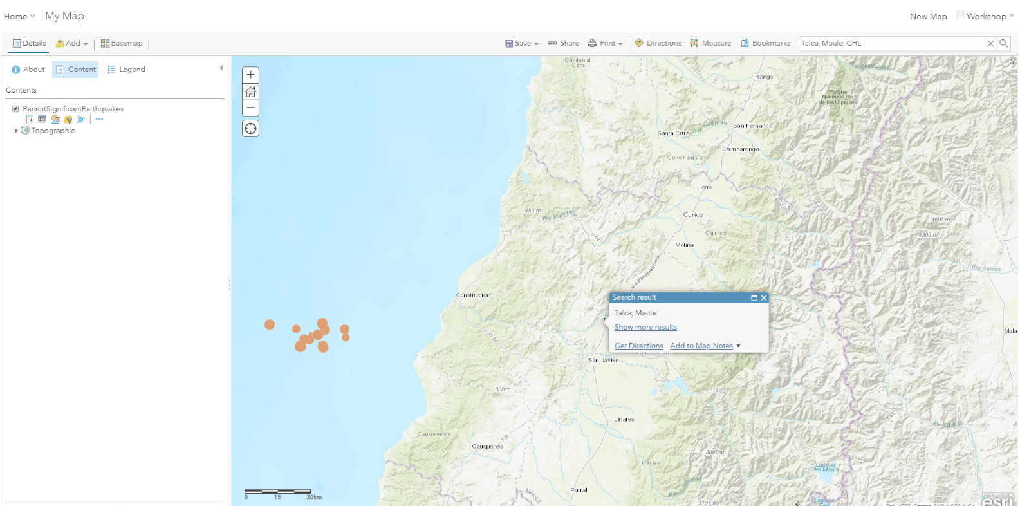

- Next hover over the Recent Significant Earthquakes Layer and click the fourth icon for Filter

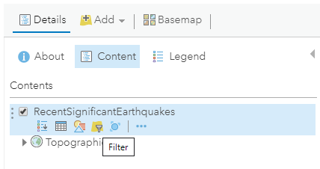

- Fill in box like below using the drop downs:
- We want to find the largest earthquake in this location by order of magnitude

First drop down select mag
Second select is
Third dropdown select tick box for unique and choose 6.7 in the dropdown

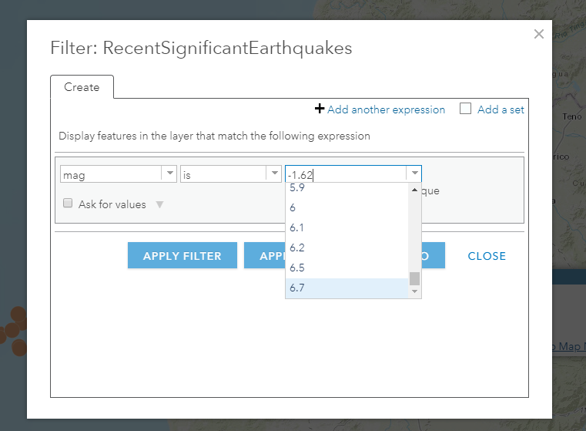
- Click 6.7 in the drop down and click apply filter and zoom to
- Zoom in on the map until you see the coast of Chile and click on the point

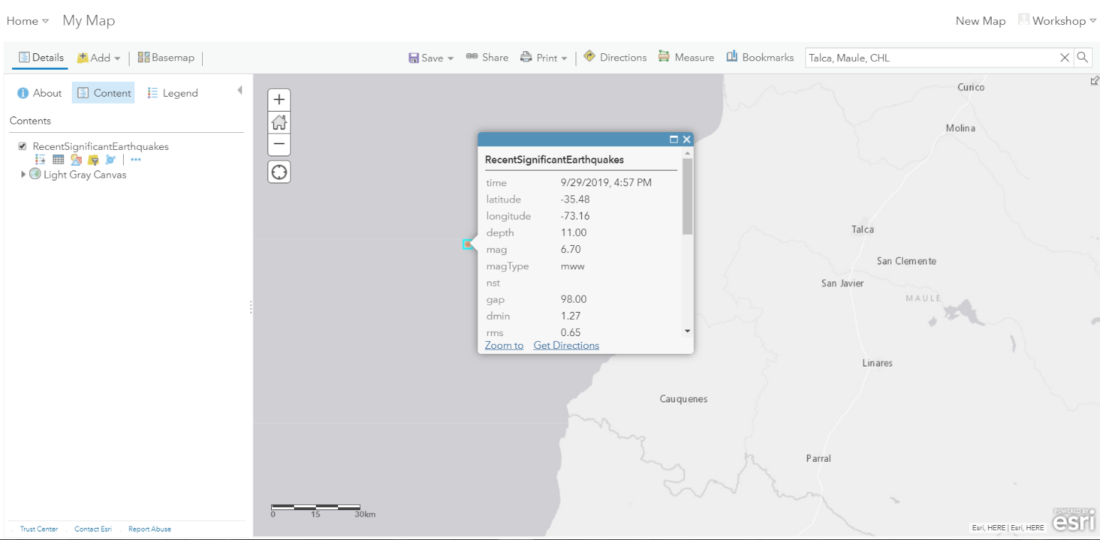
- Notice that a 6.7 magnitude earthquake happened here on the 29th of September 2019 at 4:57pm

- You can go back into filter by hovering over the layer again and click Remove filter to see all the earthquakes on the map again, we just wanted to identify the largest earthquake in this example

Next we will add more layers to the map

- Click Add
- Click Search for layers
- Click the drop down and click Search for layers in ArcGIS Online

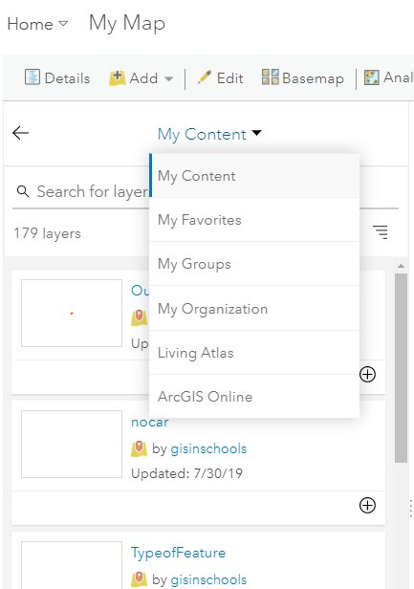

- Search for layers in ArcGIS Online
- Type or paste in the words below:

Plate boundaries

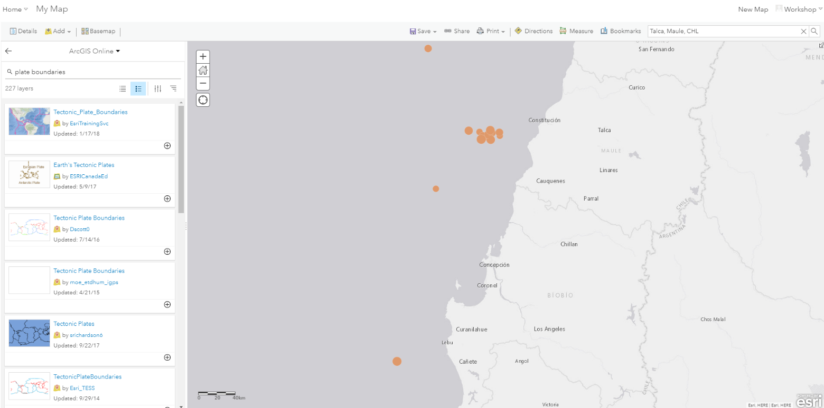
- Click the + sign to add layer to the map called:

Tectonic_Plate_Boundaries

- Scroll out and click the back arrow and Content
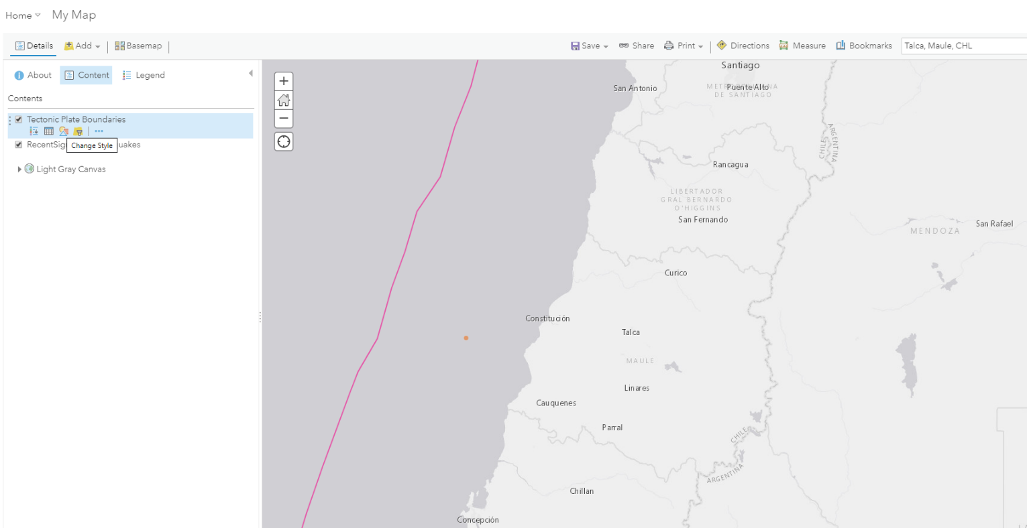
- You will see the Tectonic Plate Boundary layer in your Content tab
- Hover over the layer name and choose the third icon for change style
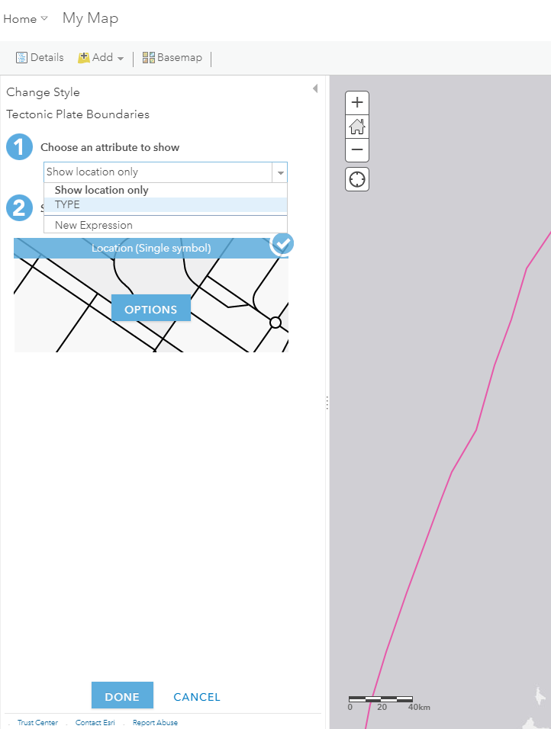
- At 1 for Choose an attribute to show click on the dropdown and click TYPE
- Click Done
- Click Legend and zoom out on the map
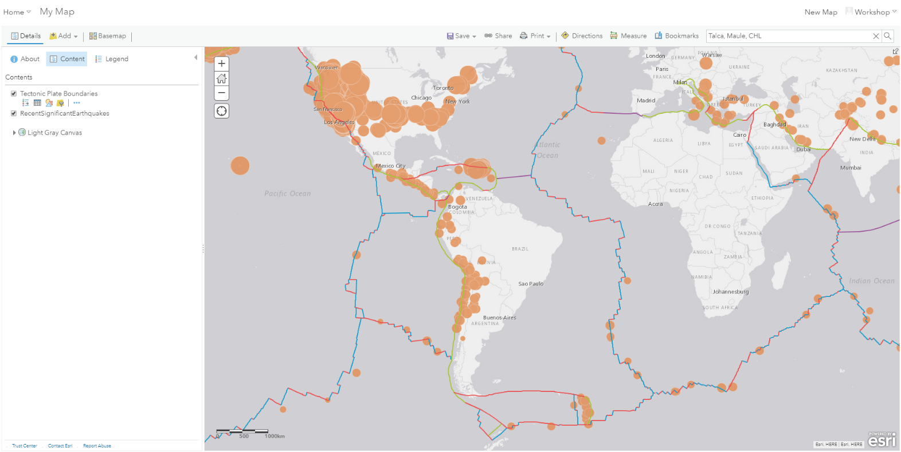
- You will notice that the earthquake we identified off the coast of Chile is close to a Converging Plate Boundary
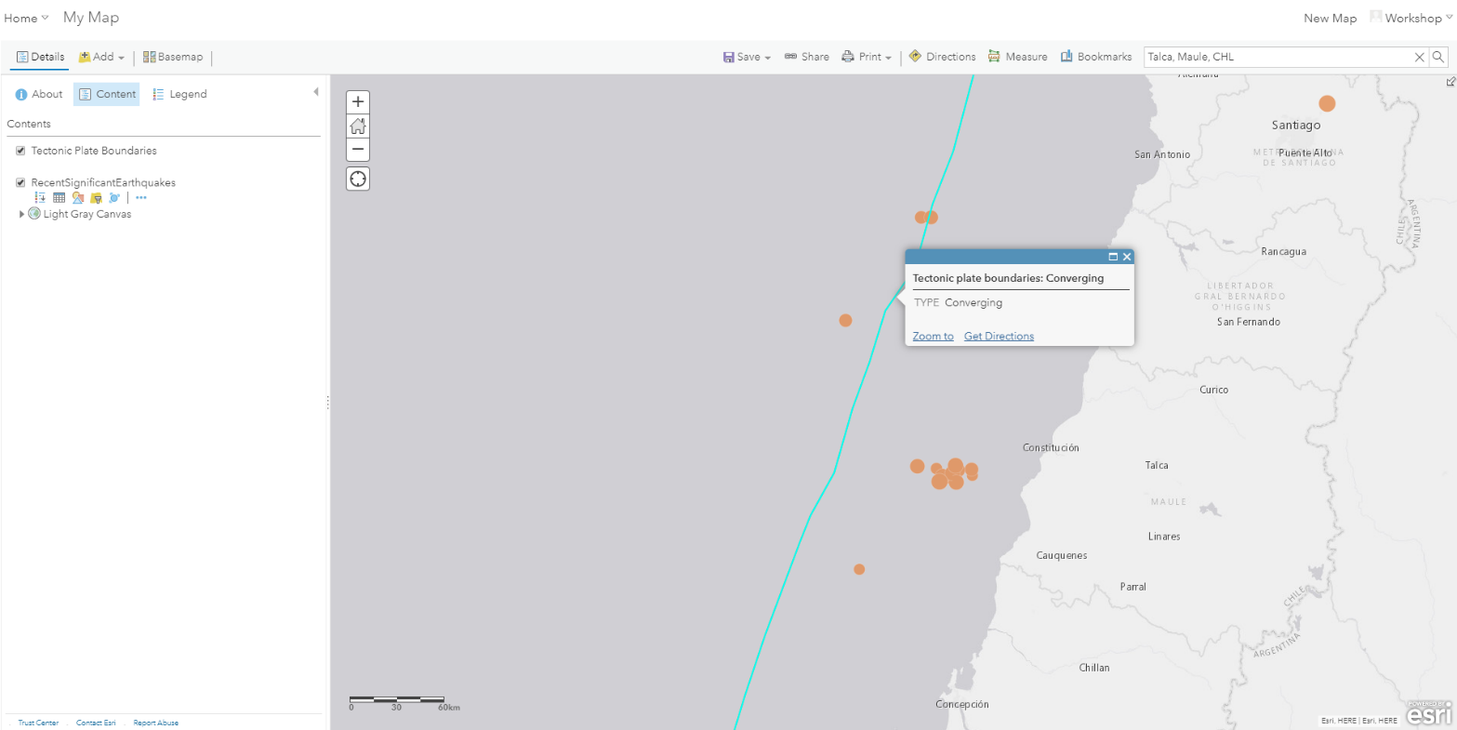

Next we will search and find more information relating to earthquakes in Chile:
- Click Add
- Click Search for layers
- Click the drop down and click Search for layers in ArcGIS Online
- Search for layers in ArcGIS Online
- Type or paste in the words below and click search:

Chile earthquakes

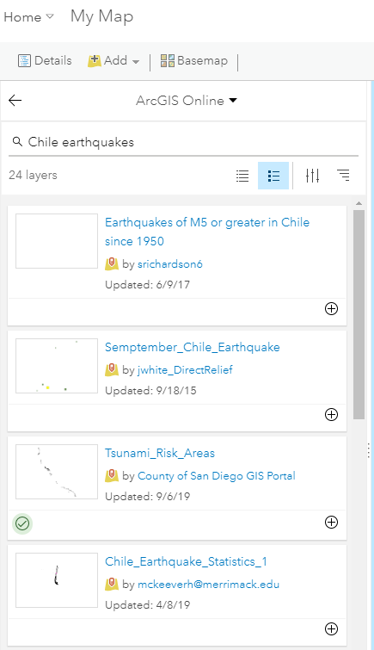

- Click the + icon on the fourth layer called to add the layer to the map:

Chile_Earthquake_Statistics_1

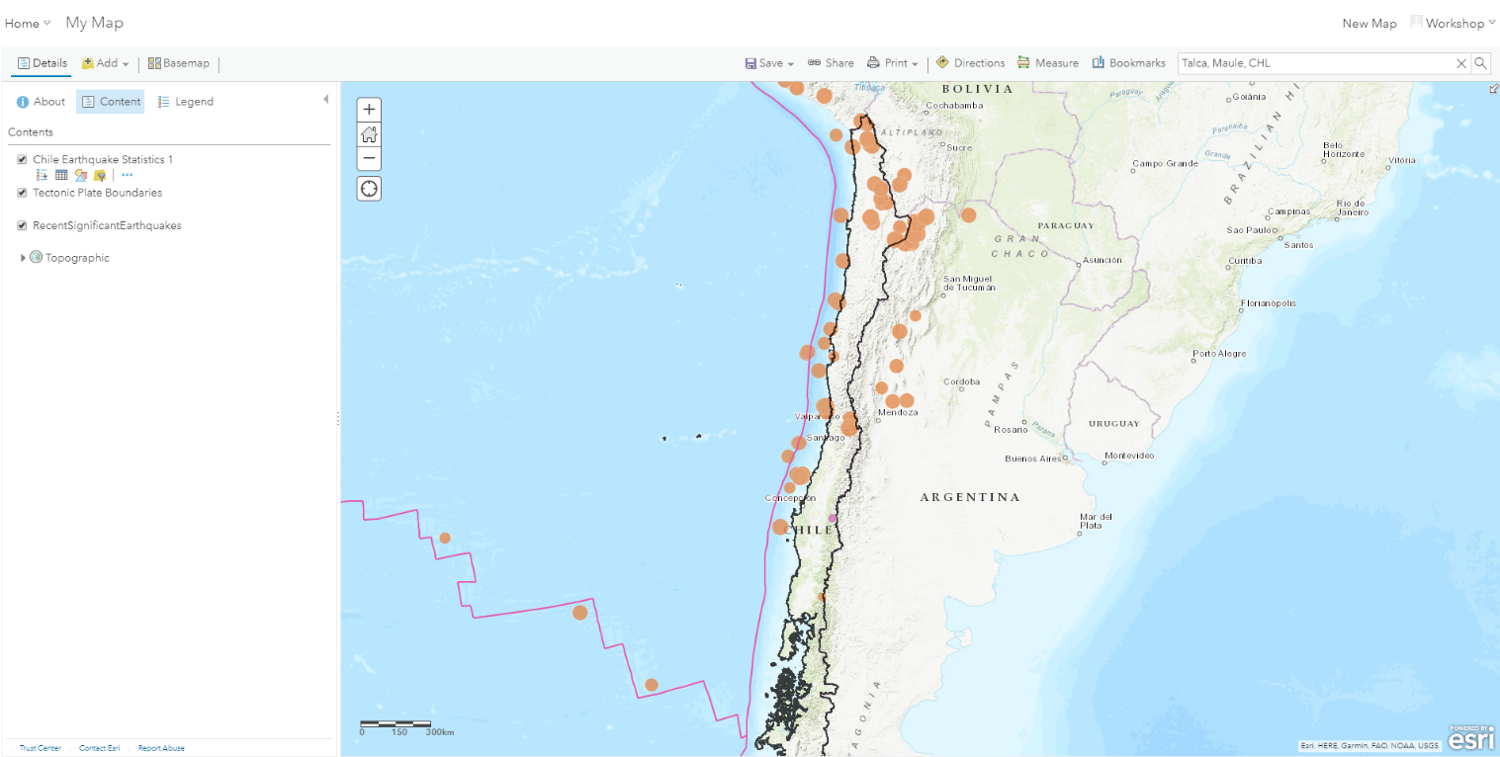

- You will see a boundary appear around Chile with a purple dot
- Click Legend and click on the boundary on the map

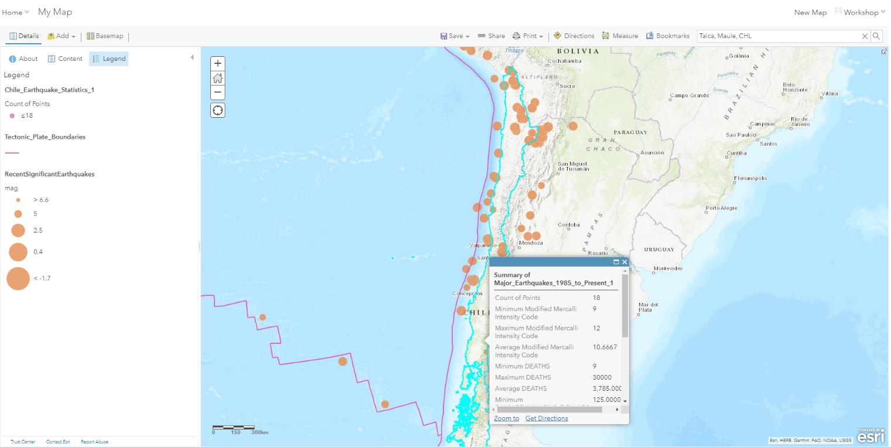

- Note the information contained in this layer about the impact of Earthquakes on Chile

For example: Cost of damage done to the country or the number of deaths as a result of Earthquakes since 1985
- Click Save as to save you map
- Use Earthquakes for the tag

Earthquakes Continued:

To continue examining Earthquakes, you could scroll in on Earthquakes in California in the USA
You could search for the layers in ArcGIS Online called to learn more about Earthquakes and their impact in the USA:

Linear Earthquake Faults
USA Earthquake Risk
USA Active Quaternary Faults

This concludes today’s workshop

You can continue using ArcGIS for Schools for different topics on the curriculum.
For example:
- You could search for different data for Ireland
- You can do this by Clicking New map
- Search for data in My Organisation again and type in

osi
- This will bring up all the Ordnance Survey Discovery base maps for Ireland

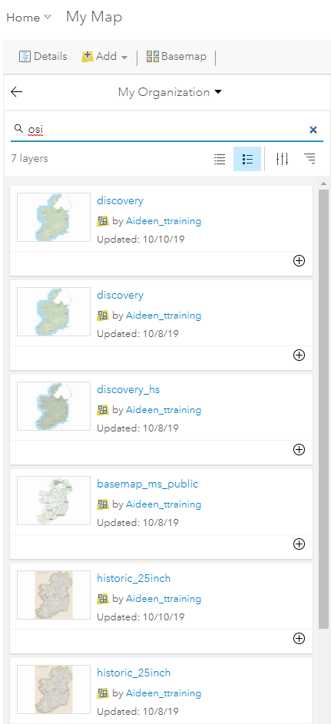

- Next you could search for data in ArcGIS Online again and type in:

census Ireland
- Click + icon on the fourth layer called:

Census 2011, Nationality, CSO, AIRO, Ireland

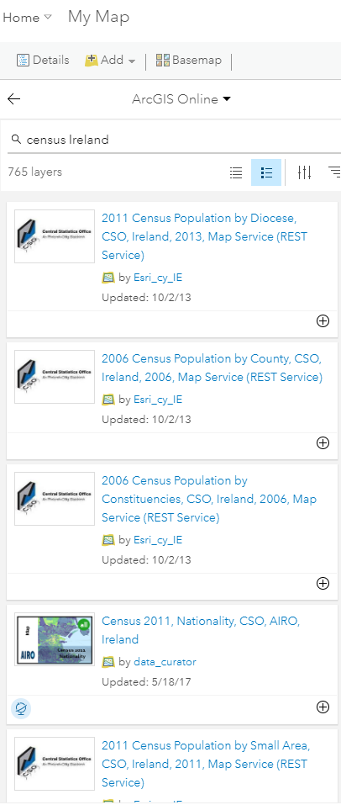

- You could use this layer to explore nationalities and the topic of migration with your class for your town
- You could also click on the 2011 Census Population by Small Area, CSO, Ireland, 2011 layer to examine populations in Ireland

Helpful Resources:
Set up Survey123
http://bit.ly/Survey123Steps
Follow up on Twitter @gisinschools
https://schools.esri-ireland.ie/sign-up/

